
COMMUNITY COMPLAINT
MANAGEMENT SYSTEM

Project Name: COMMUNITY COMPLAINT MANAGEMENT SYSTEM

Submitted By: SHAHZAIB KHAN

Submitted To: DR.UMER RASHID

Course Name: ANALYSIS AND DESIGN OF SOFTWARE SYSTEM

1. Background
Most towns still handle complaints the old way nowadays. When someone notices a problem in their area, such as a broken street light, a blocked drain, or a pile of garbage, they usually have to go to the local office and explain it in person. Some people call a helpline and discussed their complaint. Others write a letter or fill out a paper form. Once the complaint reaches the office, a staff member writes it down in a register by hand and then passes it on to the right department who solved that problem.
This way of working was fine when towns were small and complaints were few then it become easy to solved the complaint . But as cities have grown, means the number of complaints has grown with them. Offices now receive more complaints than they can properly record. Many complaints get lost or forgotten along the way because offices cannot handle many complaint at one time , and the citizen who filed one often has no way of knowing whether it was ever received or not .
Our project, the Community Complaint Management System, moves this whole process online. It gives citizens a simple way to submit a complaint and check on its progress later, and it gives staff an organized way to manage and resolve these complaints.This is the easy way to solved all the complaint on the time because all the complaint have been saved in the online portal and relevant department can easily track it and solved it .

2. Existing Tools and Technology
Most local offices still rely on tools that were never really built for handling complaints. Some of the common methods in use today that most people used are .
Phone Helplines: Many offices give out a phone number that citizens can call to report a problem. A staff member in the specific office notes down the details by hand. This depends entirely on a staff member being available and writing things down correctly, and it leaves the citizen with no record they can check later.The citizens were unknown an about their complaint and they cant track it .
Paper Registers: Offices often keep a physical register where every complaint is written by hand along with a date, name, and short description. Finding an old complaint means going through page after page, which takes time and is easy to get wrong.This cause delay in complaint resolving and there is a chance that the record of the complaint will be lost.
Spreadsheets: Some offices now use Excel or Google Sheets to record complaints. This is a step up from paper, but someone still has to update it manually, and there is no automatic tracking or alert sent back to the citizen.
Social Media Pages: Many residents post their complaints directly on the Facebook or Twitter page of a local office, and they are hoping for a quicker response. This can draw attention to a problem, but nothing about it is organized. Posts get buried, and there is no proper record of what was actually fixed.Through social media complaint can,t handle properly it will remain unresolved.
WhatsApp Groups: In some areas, informal groups run by a local councilor are used to report issues. This can work for a small neighborhood, but it does not scale to a large population and also , and it leaves no permanent record that can be searched later.
General Ticketing Software: some of the Tools like zendesk or freshdesk exist for handling customer complaints, but they are built for businesses. Local offices rarely use them, partly because of the cost, and partly because they are not designed for a citizen-to-government process.
None of these tools give a citizen an easy way to submit a complaint and follow up on it later because these tools have no a proper way of tracking the complaint and complete it . They also do not give office staff a clear, organized view of open complaints, which makes fair and timely handling difficult and at the last the issue remain unresolved .

3. Issues
The tools that we used today create many problems for both citizens and staff.
No Tracking: Once a complaint is submitted, the citizen usually has no way to check its progress or find out if it has even been assigned to someone.This cause a serious problem for the residents because they are unable to know about progress of complaint because of a no proper tracking platforms . So this cause the residents are unaware of the complaints.
Lost Complaints: The complaints through the Paper records and informal chats are easy to lose. Because a page in a register can get damaged or the record on a get lost by the staff , and a message in a group chat can simply be scrolled past and forgotten.So there is a huge chance that the complaints will be lost .
Long Delays: There is no system to flag old, unresolved complaints, so some issues stay open for months because staff have no easy way to sort complaints by how long they have been waiting.
No Proof of Submission: A citizen who calls to a offices or visits in person usually has nothing to show that a complaint was even filed this cause a serious problem for the citizen because they are unknown about the complaint are submitted or not, which makes it hard to follow up.
Duplicate Complaints: Since there is no shared record, several residents may report the same pothole without anyone realizing it is the same issue, which wastes staff time.
Wrong Department:Mostly Complaints are sometimes sent to the wrong office because there is no proper category system, which causes further delay.This is the major reasons that more complaints have not been reported .
No Data for Planning: Without a central record, it is hard for officers to see which type of complaint comes up most often, which makes long-term planning harder.
Limited Access: People who cannot easily travel to an office, or who are not comfortable calling, these people have no any other resources left to submit a complaint and that the result most of the complaint will remain unsubmitted and unresolved .
Low Trust: When citizens feel their complaints are being ignored and when there is a high chance that the departnments will not review their complaints , they slowly lose trust in the process and often stop reporting problems, even when the problem is still there.

4. Motivation
The idea for this project came from watching how complaint handling actually works in most local areas. Residents often struggle to get even a simple problem fixed, simply because there is no proper way to report it and follow up. A neighbor complaining about the same broken street light for months is a common and completely avoidable situation.
There are a few clear reasons why we think this project is worth building.
First, smartphone and internet use has grown a lot, even in small towns. Most residents today can open a website on their phone, which makes a digital complaint system practical.
Second, government offices are already being encouraged to move toward digital, paperless work, and a complaint management system fits directly into that direction.
Third, this project gives us a chance to apply what we have learned about software engineering to a real problem instead of a purely theoretical one. Building a system with real users, such as citizens and staff, gives us a much better understanding of how requirements, design, and coding connect.
Fourth, the project also involves different user roles, since citizens and staff need different types of access to the same data. This is a useful and common idea for us to practice in a real system.
Fifth, a system like this can genuinely improve transparency. If a citizen can see the exact status of a complaint, and staff have a clear list of what needs attention, both sides benefit and the complaints will be easily resolved on time .

5. Problem Statement
At present, there is no simple, organized way for citizens to report local problems and track what happens to their complaint is it delivered completely or not, this cause a serious concern after it is submitted. Complaints are handled through phone calls, paper registers, informal chat groups, or in-person visits to a offices , and none of these give the citizen a clear record of their submission or its current status.
Staff members also have no central place to view, or handle the complaints that was assigned to them, which leads to delays, repeated complaints again and again, and complaints that never get properly closed. This creates a gap between citizens and local offices and lowers public trust. The citizens get frustrated and confused completely that’s why their trust level low and they are not expecting the positive response from them.We believe there is a clear need for a system that lets citizens submit and track complaints easily, and lets staff manage and resolve them in an organized way.

6. Scope
The Community Complaint Management System is a web-based platform with two main types of users: citizens and staff. Below we outline what we are including in this project and what we are leaving out.
Included in the scope of this project:
- Citizen registration and login
- Submission of a new complaint with a category, description, location, and an optional photo
- Tracking of complaint status, such as Pending, In Progress, or Resolved
- A staff dashboard to view, assign, and update complaints
- Basic search and filtering of complaints by category, area, or status
- Simple reports showing the number of complaints by category or area
Not included in the scope of this project:
- Online payment processing, since the system does not handle money
- Direct connection to national identity or other government databases
- Live chat between citizens and staff

7. Process Model: Incremental Model
For this project we selected the Incremental Model. In this model, we do not try to build the whole system in one go. Instead, we break the project into smaller parts, called increments. Each increment goes through its own small cycle of gathering requirements, designing, coding, and testing, and it results in a working piece of the system that we can review before starting the next one.
We chose this model for a few concrete reasons. The Community Complaint Management System is a fairly new kind of system for the people who will use it, both citizens and office staff, so some requirements are likely to change once an early working version is actually seen and tried. Building everything in one long stretch, and only finding this out at the end, would be far riskier than building it piece by piece.
The nature of the system itself also supports this choice. Its features naturally split into independent parts: complaint submission, complaint tracking, the staff dashboard, and reporting. Each of these can be built, tested, and shown as a working demo on its own, without waiting for every other part to be finished. This gives us proof that the incremental approach fits the project, since we can already see a clean division of the system into four separate, working increments: citizen registration and complaint submission, complaint tracking and status updates, the staff dashboard for managing complaints, and finally search, filtering, and basic reports.
Testing after every increment, rather than only at the end, also means bugs are caught early and fixed while the related code is still fresh in our minds. By the time we reach the last increment, the core of the system is already built and tested, which lowers the overall risk of the project and gives us something working to show at almost every stage.
We did also look at the Waterfall Model, where requirements, design, coding, testing, and deployment happen one after another in a straight line, with each stage finishing completely before the next begins. We decided against it because it only allows testing at the very end, and it leaves very little room to change earlier decisions once work has started. Since we expect some requirements for this system to shift once real users interact with an early version, Waterfall was not a good fit for how we wanted to build and test this project.

8. Plan

The Community Complaint Management System will be developed using the Incremental Model, where the project will be divided into small and manageable parts. This technique will help us in developing, testing, and improving each feature step by step. This project will be completed within seven weeks if the plan is executed on time.
In the first week, we will collect system requirements and design the basic structure, database, and user interface. The second week will focus on developing citizen registration, login, and complaint submission features. In the third week, complaint tracking and status update features will be implemented because tracking the complaint is important which enable the citizen to know whether their complaint submitted correctly and is it solving or not.
The fourth week will be used to create the staff dashboard for managing , assigning, and resolving complaints.This technique is very helpful for the staff which improve the progress of the complaints . During the fifth week, more additional features such as searching, filtering, and report generation will be added.
In the sixth week, all modules will be integrated and system testing will be performed to fix errors. The final week will be used for complete system testing, documentation, and final improvements. This plan will ensure that the system is developed and built with the better quality .

COMMUNITY COMPLAINT
MANAGEMENT SYSTEM

SOFTWARE REQUIREMENTS SPECIFICATION
Submitted By: Shahzaib Khan & Dileep Singh
Submitted To: Dr. Umer Rashid
Course: Analysis and Design of Software Systems

TABLE OF CONTENTS

1. Functional Requirements 1
1.1 User Registration and Authentication 1
1.2 Complaint Submission 1
1.3 Complaint Tracking 1
1.4 Staff Dashboard 1
1.5 Search, Filtering, and Reporting 2
2. Non-Functional Requirements 3
3. Software Requirements 4
4. Hardware Requirements 5
4.1 Server-Side Requirements 5
4.2 Client-Side Requirements 5
5. Constraints 6
6. Use Case Descriptions 7
6.1 System Actors 7
6.2 Register Account 7
6.3 Login 8
6.4 Submit Complaint 8
6.5 Track Complaint Status 9
6.6 View Complaint History 9
6.7 Rate / Give Feedback 10
6.8 Update Profile 10
6.9 Search Complaints 11
6.10 Assign Complaint 11
6.11 View Assigned Complaints 12
6.12 Resolve / Update Complaint 13
6.13 Manage Users 13
6.14 Manage Categories 14
6.15 Generate Reports 14
6.16 Escalate Complaint 15
6.17 View Admin Dashboard 15
6.18 Send Notification 16
7. Use Case Diagram 17

COMMUNITY COMPLAINT MANAGEMENT SYSTEM
Software Requirements Specification (SRS)

This document explains the Software Requirements Specification (SRS) for the Community Complaint Management System. It describes what the system should do, how it should work, and the limits of the project. These requirements will help the development team design and build the system correctly. They also provide a clear guide to make sure the final system is complete and meets the project goals.

1. FUNCTIONAL REQUIREMENTS
Functional requirements actually describe the what the system will do. It describe the specific actions and features the system must support for its two categories of users, citizens and staff. These are grouped below by the module they belong to, so that related features can be read together,in unordered list.

1.1 User Registration and Authentication
1 The system shall allow a every new citizen to register an account by writing their name, a valid email address or phone number, and a password.
2 The system shall allow a registered citizen to log in using their registered credentials for example email and passoward .
3 The system shall provide a password recovery option for citizens who forget their login details.
4 The system shall provide a separate login for staff members, using credentials created and issued by an administrator.
5 The system shall allow a citizen to view and update basic profile information after logging in.So it helps the citizen to update their profile information and view it any time.

1.2 Complaint Submission
6 The system shall allow a logged-in citizen to submit a new complaint by selecting a category,by entering a description about the complaint that the citizen wanted to registers, and it should provide , specifying the location of the issue.
7 The system shall allow a citizen to optionally attach a photo when submitting a complaint.
8 The system has the responsibility to automatically generate a unique complaint ID for every complaint that was submitted , because through complaint ID it was tracking easily.
9 The system shall set the initial status of a newly complaint that was submitted by the citizen to Pending.

1.3 Complaint Tracking
10 The system shall allow a citizens to view the current status of their complaint that was submitted by them, using their account or the unique complaint ID.
11 The system shall maintain a history of all complaints submitted by a citizen to maintain the record of evert complaint that was submitted at any time , visible from their account.
12 The system shall update the citizen by sending the notification on their email or phone no when the status of their complaint changes.

1.4 Staff Dashboard
13 The system shall provide staff with a dashboard that was essential for listing all complaints in a specific sequence order, along with their category, status, and submission date.
14 The system shall allow staff to assign the complaint that was unassigned to a department or staff member.
15 The system shall allow staff to update the status of a complaint, like change the status from Pending to In Progress or Resolved.This will help the citizen to know the progress of their report.
16 The system shall allow staff to add a short remark or notice when updating a complaint.

1.5 Search, Filtering, and Reporting
17 The system shall allow staff to search complaints using the keywords.
18 The system shall allow staff to filter complaints by category, area, or status.
19 The system shall generate basic reports showing the number of complaints grouped by category or area.

2. NON-FUNCTIONAL REQUIREMENTS
Non-functional requirements describe the quality attributes of the system should have rather than a specific feature. These matter just as much as the functional requirements, since a system that technically works but is slow, confusing, or insecure would not actually solve the problem it was built for.So non functional requiremments are important for making the system stable and good for the citizen .
1 Usability The interface shall be simple , easy to use for a citizen with no technical background can submit and track a complaint without any training or written instructions and it has features to simply add the complaints without knowing about the system how it works.
2 Performance The system shall load pages and respond to common actions, such as submitting a complaint or searching, within three seconds under normal load.The performance matter most in the system because a good system has a better performance and fast execution and it manage the activities rapidly.
3 Reliability The system shall not lose a submitted complaint once it has been saved , it should saved it permanently in any database records, and shall keep the complaint record consistent even if the citizen closes the browser mid-session.
4 Security The system shall store passwords in encrypted form for security to other users and shall restrict access to staff features so that citizens cannot view or modify complaints belonging to other users.
5 Availability The system, being web-based, shall be accessible to citizens and staff at any time, subject to normal server maintenance windows.
6 Maintainability The system shall be built using a modular structure so that we can easily make the change in individual features, such as reporting or search , can be updated without affecting the rest of the system and its functionality.
7 Scalability The system shall be able to handle a growing number of complaints submitting and registered users as adoption increases, without a significant drop in performance.The performance should be remain unchanged if more complaints are adding into the system.
8 Portability The system shall be accessible from any modern web browser on both desktop and mobile devices, without requiring a separate installation.

3. SOFTWARE REQUIREMENTS
The following softwares and technologies are needed to be used to build the system more unique and make the system completely executable and run able . These choices are based on which is freely available and easy to use , well documented, and suitable for a project of this scope.
- Operating System: Windows or Linux, for both the development machine and the hosting server.
- Frontend Technologies: HTML5, CSS3, and JavaScript, used to build the citizen and staff interfaces.
- Backend Technology: A server-side framework such as PHP (Laravel) or Node.js (Express), used to handle requests and business logic.
- Database Management System: MySQL, used to store citizen accounts, staff accounts, and complaint records.
- Development Tools: Visual Studio Code as used for the primary code editor, along with Git and GitHub for version control.These development tools are needed for unique development of the system.
- Web Browser Compatibility: The system shall run correctly on current versions of yayhoo,duckduckgo,google,Google Chrome, Mozilla Firefox, and Microsoft Edge.
- Diagramming and Documentation Tools: Draw.io and Microsoft Word, used for design diagrams and documentation.

4. HARDWARE REQUIREMENTS
Hardware requirements are like what is needed on the server side to host the system, and what is expected on the client side for a citizen or staff member to use it comfortably and easy to use.

4.1 Server-Side Requirements
- Processor: Dual-core processor or higher.
- RAM: A minimum of 4 GB, with 8 GB recommended for smoother performance under load.
- Storage: At least 50 GB of available storage to hold the database and uploaded complaint photos and related videos about the complaint.
- Network: A stable internet connection to keep the hosted system accessible at all times without the any disturbance.Like strong wifi connection.

4.2 Client-Side Requirements
- Any desktop, laptop, or smartphone that are able of running a modern web browser.
- A minimum of 2 GB RAM for a smooth and greater performance browsing experience.
- A working internet connection all the times, since the system is completely web-based and has no offline mode.

5. CONSTRAINTS
- In a Software Requirements Specification (SRS), Constraints are known as the limitations, rules, and the conditions that the system or development team must follow up while designing, developing, and deploying the software.

- Time Constraint: The project is being developed and managed within an academic semester timeline of almost seven weeks, which limits it how many features can be fully built and tested in the project.
- Team Size: The system is being developed by a two-member team, which limits the amount of work that can be done in parallel.
- Budget Constraint: Only free and open-source tools are used for development because there is a budget issue and student in a small team cannot handle it properly , since this is a student project with no funding for licensed software or paid hosting.
- No Payment Handling: The system does not process any online payments because this system has no need for the online payments options, as complaint management does not involve monetary transactions.
- No Government Database Integration: The system does not connect to national identity databases or other government systems, since access to such systems is outside student reach.
- Platform Constraint: The system is delivered as a responsive web application only; a dedicated native mobile app is not part of this project.
- Language Constraint: The initial version of the system supports English and Urdu only.
- Internet Dependency: Both citizens and staff require an active internet connection to use the system, since no offline mode is provided.Because this a a online complaint system so for making the complaint online everyone will need a stable internet connection for managing their complaint properly.

6. USE CASE DESCRIPTIONS
This section of our SRS describes the use cases of the system in detail. Each description includes the actor involved in the system, the goal of the each use case, the conditions that must hold before and after it runs, and the sequence of steps a user must follows it to complete it. Together, these descriptions explain not just what the system does, but how a citizen, department officer, admin, or the system itself actually interacts with it to get something done.

6.1 System Actors
Before the individual use cases are described, this section defines the four actors who interact with the Community Complaint Management System are citizen , department officer, admin, system(notifier).
Actor | Role in the System
Citizen | Registers an account, submits and tracks complaints, views complaint history, rates or feedback of resolved complaints, updates their profile, and searches their own complaints.
Department Officer | A staff member who reviews the complaints assigned to their department, and resolves or updates them.
Admin | A staff member with system-wide oversight who assigns complaints, manages user accounts and complaint categories, escalates unresolved complaints, generates reports, and monitors the admin dashboard.
System (Notifier) | The automated part of CCMS, rather than a human user, that sends a notification to the citizen whenever a complaint is assigned, updated, or resolved in the system.

USE CASES :

6.2 Register Account
Use Case ID | UC-01
Use Case Name | Register Account
Primary Actor | Citizen
Description | Allows a new citizen to create an account on the platform by providing basic personal details, which is required most before a complaint can be submitted.
Precondition | The citizens must have a internet access and is not already registered on that system it should be his first time to register on a system.
Main Flow | 1. Citizen opens the registration page from the homepage.  2. Citizen enters full name, email or phone number, and a password.  3. System checks whether the entered email or phone number is already registered.  4. System validates the format of the entered information.  5. System creates a new account and stores the citizen's details in the database.  6. System displays a confirmation message and show a message to the citizen to the login page.
Alternate Flow | If the email or phone number is already registered in a system , the system rejects the request and asks the citizen to log in instead because citizen is already login in this system and no need to register again or use a different email/phone number.
Postcondition | A new citizen account is created and stored in the system, and the citizen can now log in.

6.3 Login
Use Case ID | Use Case-02
Use Case Name | Login
Primary Actor | Citizen / Department Officer / Admin
Description | Allows a citizen, department officer, or admin to access their respective account after entering valid credentials.These includes email address and passoward.
Precondition | The user already has a registered account or issued credentials on the system.
Main Flow | 1. User opens the login page and selects their role: citizen, department officer, or admin.  2. User enters their registered email or username and password.  3. System verifies the entered credentials against the stored records.  4. System identifies the role of the user and redirects them to the appropriate dashboard.
Alternate Flow | If the credentials entered do not match any record, the system displays an error message and allows the user to try again because their login email and passoward did not match well on the login page or reset their password.
Postcondition | The user is authenticated first and then taken to their dashboard according to their role.

6.4 Submit Complaint
Use Case ID | UC-03
Use Case Name | Submit the Complaint on portal
Primary Actor | Citizen
Description | Allows a login citizen to report a local problem or the any issues that they have by filling out a complaint form with the relevant details.
Precondition | The citizen is registered and logged into the system.
Main Flow | 1. Citizen selects the option to file a new complaint.  2. Citizen selects a category for the complaint, such as street light, drainage, or garbage.  3. Citizen enters a short description of the problem and the location where it occurred.  4. Citizen optionally attaches a photo of the issue.The is important about seeing the more details about the issues and they authenticate it by knowing the problem exist or not according to the information provided.disk storage  5. Citizen submits the complaint form.  6. System generates a unique complaint ID and saves the complaint with a status of Pending.  7. System displays the complaint ID to the citizen as proof of submission.
Alternate Flow | If a required field, such as category or description, is left empty, the system highlights the missing field and does not allow submission until it is completed.
Postcondition | A new complaint record is created and made visible to admin for review and assignment.

6.5 Track Complaint Status
Use Case ID | UC-04
Use Case Name | Track Complaint Status
Primary Actor | Citizen
Description | Allows a citizen to check the current status of a complaint they previously submitted, using either their account history or the complaint ID.
Precondition | The citizen has previously submitted at least one complaint.
Main Flow | 1. Citizen logs in and opens the 'My Complaints' section, or enters their complaint ID on the tracking page.  2. System retrieves the record matching the complaint ID or citizen account.  3. System displays the current status of the complaint, such as Pending, In Progress, or Resolved, along with any remarks added by the assigned department officer.
Alternate Flow | If the complaint ID entered does not exist in the system, an appropriate message is shown that informing the citizen that no matching record was found please try again your id is not found in our system.
Postcondition | The citizen is shown the up-to-date status of the selected complaint.

6.6 View Complaint History
Use Case ID | UC-05
Use Case Name | View Complaint History
Primary Actor | Citizen
Description | Allows a citizen to view a consolidated list of every complaint they have ever submitted, regardless of its current status.
Precondition | The citizen is logged in and has submitted at least one complaint in the past.
Main Flow | 1. Citizen opens the Complaint History section from their account.  2. System retrieves every complaint linked to the citizen's account.  3. System displays the complaints in a list, showing the complaint ID, category, date submitted, and current status for each.  4. Citizen selects any entry to view its full details.
Alternate Flow | If the citizen has not submitted any complaints yet, the system displays a message indicating that no complaint history is available.
Postcondition | The citizen is shown a complete record of their past and ongoing complaints.

6.7 Rate / Give Feedback
Use Case ID | UC-06
Use Case Name | Rate / Give Feedback
Primary Actor | Citizen
Description | Allows a citizen to rate the resolution of a complaint and leave written feedback once it has been marked Resolved.
Precondition | The citizen is logged in and has at least one complaint with a status of Resolved that has not yet been rated.
Main Flow | 1. Citizen opens a resolved complaint from their complaint history.  2. Citizen selects a satisfaction rating, such as a star rating out of five.  3. Citizen optionally writes a short comment describing their experience.  4. Citizen submits the rating and feedback.  5. System stores the feedback against the complaint record.
Alternate Flow | If the citizen tries to rate a complaint that has already been rated, the system shows the previously submitted rating and does not allow a duplicate submission.
Postcondition | The feedback is saved and becomes available to admin for service-quality review.

Use Case ID | UC-07
Use Case Name | Update Profile
Primary Actor | Citizen / Department Officer
Description | Allows a citizen or department officer to view and edit their basic account information, such as name, contact details, or password.
Precondition | The user is logged into their account.
Main Flow | 1. User opens the Profile section from their account menu.  2. System displays the user's current profile information.  3. User edits the desired fields, such as phone number or password.  4. User saves the changes.  5. System validates the updated information and stores it.
Alternate Flow | If the updated information fails validation, such as an invalid phone number format, the system highlights the error and does not save the change until it is corrected.
Postcondition | The user's profile reflects the newly updated information.

6.9 Search Complaints
Use Case ID | UC-08
Use Case Name | Search Complaints
Primary Actor | Citizen / Department Officer
Description | Allows a citizen to search within their own complaints, and a department officer to search across the complaints assigned to their department, using keywords and filters such as category, area, or status.
Precondition | The user is logged in and complaint records exist that are visible to them.
Main Flow | 1. User opens the complaints list from their dashboard.  2. User enters a keyword or selects filter options such as category, area, or status.  3. System applies the selected filters and displays only the matching complaints within the scope the user is permitted to see.
Alternate Flow | If no complaint matches the applied filters, the system displays a message indicating that no results were found and allows the user to modify the filters.
Postcondition | The user is shown a filtered list of complaints matching the given criteria.

6.10 Assign Complaint
Use Case ID | UC-09
Use Case Name | Assign Complaint
Primary Actor | Admin
Description | Allows admin to assign a newly submitted complaint to the department officer responsible for resolving it. This use case includes Send Notification, so the citizen is informed once their complaint is assigned.
Precondition | Admin is logged in and at least one unassigned complaint exists in the system.
Main Flow | 1. Admin opens the dashboard and views the list of unassigned complaints.  2. Admin selects a complaint to review its details.  3. Admin assigns the complaint to the relevant department officer.  4. System updates the complaint record, changes its status to In Progress, and triggers Send Notification.
Alternate Flow | If the complaint was raised under the wrong category, admin can reassign it to a more suitable department before proceeding.
Postcondition | The complaint is linked to a responsible department officer, is marked as being actively handled, and the citizen has been notified of the assignment.

6.11 View Assigned Complaints
Use Case ID | UC-10
Use Case Name | View Assigned Complaints
Primary Actor | Department Officer / Admin
Description | Allows a department officer or admin to view the list of complaints that have been assigned to them, so they can plan and begin resolution work.
Precondition | The user is logged in and at least one complaint has been assigned to them.
Main Flow | 1. User opens the Assigned Complaints section of the dashboard.  2. System retrieves all complaints currently assigned to the user.  3. System displays the complaints along with their category, status, and submission date.  4. User selects a complaint to view its full details before acting on it.
Alternate Flow | If no complaints are currently assigned to the user, the system displays a message indicating that the assigned list is empty.
Postcondition | The user has a clear view of the complaints and awaiting their action, and may proceed to Resolve / Update Complaint.

6.12 Resolve / Update Complaint
Use Case ID | UC-11
Use Case Name | Resolve / Update Complaint
Primary Actor | Department Officer / Admin
Description | Allows a department officer or admin to update the progress of a complaint that is being worked on, and to close it once it has been resolved. This use case extends View Assigned Complaints and includes Send Notification, so the citizen is informed whenever the status changes.
Precondition | The complaint has already been assigned, and the department officer or admin is logged in.
Main Flow | 1. User opens an assigned complaint from the dashboard.  2. User reviews the details and works on resolving the reported issue.  3. User updates the status field, for example from In Progress to Resolved.  4. User optionally adds a short remark describing the action taken.  5. System saves the update and triggers Send Notification to inform the citizen of the change.
Alternate Flow | If the issue cannot be resolved immediately, the user can leave the status as In Progress and add a remark explaining the expected delay.
Postcondition | The complaint record reflects the latest status, the citizen has been notified, and the citizen can view the updated progress.

6.13 Manage Users
Use Case ID | UC-12
Use Case Name | Manage Users
Primary Actor | Admin
Description | Allows admin to view, create, edit, or deactivate citizen and department officer accounts to keep system access accurate and secure.
Precondition | Admin is logged in with user-management privileges.
Main Flow | 1. Admin opens the Manage Users section of the dashboard.  2. System displays a list of registered citizens and department officers.  3. Admin selects a user to view, edit, or deactivate their account.  4. Admin saves the change.  5. System updates the user's record accordingly.
Alternate Flow | If admin attempts to deactivate an account that has active, unresolved complaints assigned to it, the system warns admin and asks for confirmation before proceeding.
Postcondition | The user account list reflects the changes made by admin.

6.14 Manage Categories
Use Case ID | UC-13
Use Case Name | Manage Categories
Primary Actor | Admin
Description | It Allows admin to add, edit, or remove the complaint categories in the dashboard that citizens choose from when submitting a complaint.
Precondition | Admin is logged in with category manage details.
Main Flow | 1. Admin opens the Manage Categories section of the dashboard.  2. System displays the list of existing complaint categories.  3. Admin adds a new category, or selects an existing one to edit or remove.  4. Admin saves the change.  5. System updates the list of categories available to citizens.
Alternate Flow | If admin tries to remove a category that still has complaints linked to it, the system prevents the deletion and suggests reassigning those complaints first.
Postcondition | The set of complaint categories offered to citizens reflects admin's changes.

6.15 Generate Reports
Use Case ID | UC-14
Use Case Name | Generate Reports
Primary Actor | Admin
Description | Allows admin to view a summary of complaint data, such as the number of complaints received by category or area, to support planning and review.
Precondition | Admin is logged in and has access to reporting privileges.
Main Flow | 1. Admin opens the reports section from the dashboard.  2. Admin selects the type of report needed, such as complaints by category or by area.  3. System compiles the relevant data from the complaint records.  4. System displays the report as a simple chart .
Alternate Flow | If there is not enough data for the selected report, the system displays a message indicating that insufficient records are available.
Postcondition | Admin is shown a summary report completely that can support decisions about resource allocation and recurring problem areas.

6.16 Escalate Complaint
Use Case ID | UC-15
Use Case Name | Escalate Complaint
Primary Actor | Admin
Description | Allows admin to escalate a complaint that has remained unresolved beyond the expected timeframe, or that requires higher-level attention.
Precondition | Admin is log in and has identified a complaint that is overdue or requires escalation.
Main Flow | 1. Admin opens the complaint that needs escalation.  2. Admin marks the complaint as escalated and records a reason.  3. System raises the priority level of the complaint and flags it for closer follow-up.  4. System keeps the citizen's visible status updated to reflect that the complaint is receiving additional attention.
Alternate Flow | If the complaint is resolved before the escalation is confirmed, admin can cancel the escalation instead because there is no need for escalation if it has been resolved
Postcondition | The complaint is flagged as escalated and prioritised for faster resolution.

6.17 View Admin Dashboard
Use Case ID | UC-16
Use Case Name | View Admin Dashboard
Primary Actor | Admin
Description | It gives admin a single overview screen summarising complaint volumes, statuses, and recent activity update that was across the whole system.
Precondition | Admin is logged in.
Main Flow | 1. Admin logs in and is directed to the admin dashboard.  2. Systeem compiles summary figures, such as total complaints, pending complaints, and complaints resolved this week.  3. System displays the figures alongside shortcuts to Assign Complaint, Manage Users, Manage Categories, and Generate Reports.
Alternate Flow | If summary data cannot be compiled, for instance due to a temporary system issue or any fault in the system temporarily, the dashboard shows the last successfully generated figures along with a notice that they may not be the current.
Postcondition | Admin has an up-to-date overview of system activity to guide their next action.

6.18 Send Notification
Use Case ID | UC-17
Use Case Name | Send Notification
Primary Actor | The System (Notifier)
Description | An automated use case, triggered by assign Complaint and Resolve / Update Complaint, that informs a citizen whenever their complaint's status changes.This simply sends a notify message to the citizen about their complaint.
Precondition | A complaint has just been assigned, updated, or resolved completely.
Main Flow | 1. System detects a status-changing event on a complaint, such as an assignment or a resolution update.  2. System composes a short notification that is related to describing the change.  3. System delivers the notification to the citizen through the channel used at registration, such as email or SMS.  4. System logs the notification as sent against the complaint record submitted by the citizens.
Alternate Flow | If the notification cannot be delivered, for example due to an invalid contact address, the system retries once and logs the delivery failure without blocking the underlying complaint update.
Postcondition | The citizen has been informed of the change to their complaint, and a delivery record is stored.

7. USE CASE DIAGRAM
This use case diagram brings together all the use cases described in the use case description section, showing how the four actors of the system, Citizen, Department Officer, Admin, and System (Notifier), interact with the system. A citizen can do many functionality in the system like registers, login, submits complaints, tracks their progress, views their history, updates their profile, and rates the service once it is resolved. A department officer login to view the complaints that was submitted by the citizens and assigned it to their respective department and resolve or update them on time. An admin login to assign complaints, manage users account and categories, also manage the escalate complaints, generate reports, and monitor the admin dashboard. The system itself, acting as the Notification alerts that sends a notification when a complaint is assigned, updated, or resolved.
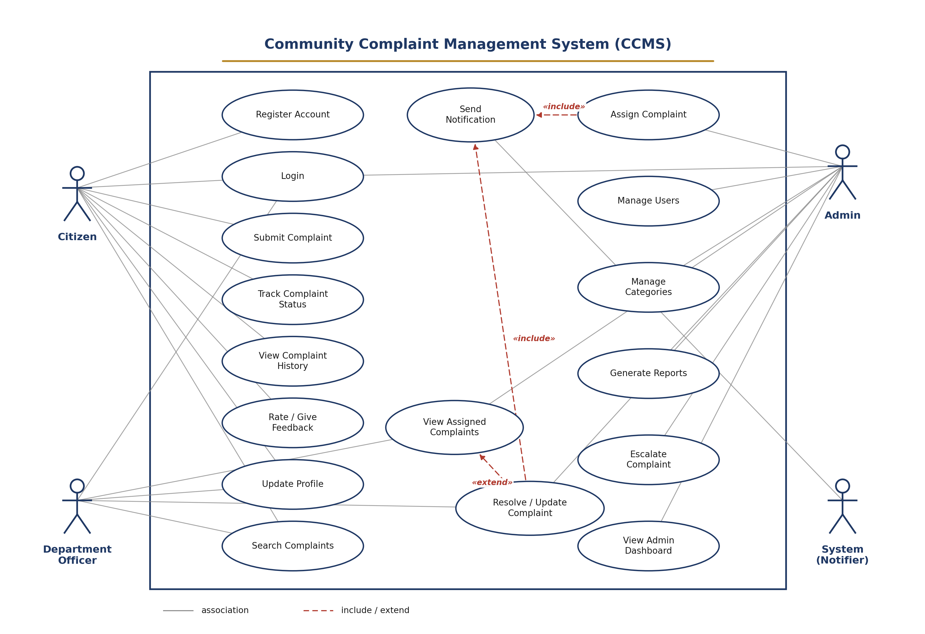
Use Case Diagram of the Community Complaint Management System

COMMUNITY COMPLAINT MANAGEMENT SYSTEM
Analysis Documentation
Domain Model | Data Flow Diagrams | System Sequence Diagrams

Submitted By: Shahzaib Khan
Submitted To: Dr. Umer Rashid
Course: Analysis and Design of Software Systems
Assignment 3 - Analysis Documents

Table of Contents
1. Introduction 4
1.1 Purpose of this Document 4
1.2 Scope 4
1.3 How this Document is Organised 4
2. Domain Model 4
2.1 What the Domain Model Represents 4
2.2 Domain Classes 5
2.3 Relationships Between the Classes 5
2.4 Domain Model Diagram 6
2.5 Traceability to the SRS 6
3. Data Flow Diagrams 7
3.1 What a Data Flow Diagram Shows 7
3.2 External Entities and Data Stores 7
3.3 Context Diagram (Level 0) 7
3.4 Level 1 Data Flow Diagram 8
3.5 Level 2 Data Flow Diagram 10
3.6 Data Dictionary 10
4. System Sequence Diagrams 11
4.1 What a System Sequence Diagram Shows 11
4.2 SSD - Register Account (UC-01) 11
4.3 SSD - Login (UC-02) 11
4.4 SSD - Submit Complaint (UC-03) 12
4.5 SSD - Track Complaint Status (UC-04) 12
4.6 SSD - Assign Complaint (UC-09) 12
4.7 SSD - Resolve / Update Complaint (UC-11) 13
4.8 SSD - View Complaint History (UC-05) 13
4.9 SSD - Generate Reports (UC-14) 14
4.10 SSD - Manage Categories (UC-13) 14
5. Conclusion 15

List of Figures
Figure 2.1 - Domain Model of the Community Complaint Management System 6
Figure 3.1 - Context Diagram (Level 0) of CCMS 7
Figure 3.2 - Level 1 Data Flow Diagram of CCMS 9
Figure 3.3 - Level 2 Data Flow Diagram of Process 2.0 (Submit Complaint) 10
Figure 4.2 - System Sequence Diagram for Register Account 11
Figure 4.3 - System Sequence Diagram for Login 11
Figure 4.4 - System Sequence Diagram for Submit Complaint 12
Figure 4.5 - System Sequence Diagram for Track Complaint Status 12
Figure 4.6 - System Sequence Diagram for Assign Complaint 13
Figure 4.7 - System Sequence Diagram for Resolve / Update Complaint 13
Figure 4.8 - System Sequence Diagram for View Complaint History 13
Figure 4.9 - System Sequence Diagram for Generate Reports 14
Figure 4.10 - System Sequence Diagram for Manage Categories 14

1. Introduction

1.1 Purpose of this Document
This document is related to the Analysis submission for the Community Complaint Management System project. It follows on from the Software Requirements Specification (SRS) that was submitted earlier and takes the functional requirements and use cases described there into a set of analysis models. The purpose of these models is to look at the problem from the inside, that is, to work out what real-world things the system needs to keep information about, how that information moves between the differnt parts of the system, and how a single interation between a user and the system actually plays out step by step. None of the models in this document talk about how the system will be coded or which framework will be used; that is left for the design stage. At this stage of analysis docunments the goal is simply to understand and organise the problem correctly before any design decision is made.

1.2 Scope
The analysis presented here covers the same four actors that were defined in the our precious docunmnets SRS, namely Citizen, Department Officer, Admin, and the System itself acting as an automatic Notifier. It also covers every use case listed in section 6 of the SRS, from account registration up to sending a notification once a complaint is updated. Three kinds of analysis artefacts are produced for this assignment:
- A Domain Model, which identifies the main real-world classes involved in the system (Citizen, Complaint, Category, Staff, etc.), their attributes, and the relationships between them.
- Data Flow Diagrams , drawn at the Context level (Level 0), Level 1, and a further decomposition (Level 2) of one of the more detailed processes, showing how data flows between external entities, processes, and data stores.
- System Sequence Diagrams drawn for nine of the more significant use cases, showing the sequence of messages passed between an actor and the system treated as a single unit.

1.3 How this Document is Organised
In Section of my documents 2 presents the Domain Model. Section 3 presents the Data Flow Diagrams at three levels of detail. Section 4 presents the System Sequence Diagrams for the selected use cases. Section 5 closes the document with a short summary of how the three models fit together and feed into the design phase of the project.

2. Domain Model

2.1 What the Domain Model Represents
A domain model is a picture of the real-world concepts that the system needs to remember, without saying anything about databases, tables, or code. It is drawn as a set of classes connected by lines that show how the classes relate to one another, along with the number of objects that can take part in each relationship. The domain model for CCMS was built directly from the nouns and short descriptions found throughout the SRS, in particular the actor descriptions in section 6.1 and the fields mentioned in the functional requirements and use case flows.

2.2 Domain Classes
The table below lists the classes identified for CCMS along with a short description of what each one stands for.
Class | Description
Citizen | A resident who registers on the platform, submits complaints, tracks them, and rates the resolution once a complaint has been closed.
Staff | A general term for a system user who is not a citizen. Admin and Department Officer are both kinds of Staff and share the same basic login details.
Admin | A member of staff with system-wide privileges. Assigns complaints, manages user accounts and categories, escalates overdue complaints, and generates reports.
Department Officer | A member of staff attached to a particular department who works on the complaints that have been assigned to that department.
Complaint | The central record of the system. Represents a single problem reported by a citizen, together with its category, location, description, photo, and current status.
Category | A classification such as street light, drainage, or garbage that a citizen chooses when filing a complaint, and that Admin can add, edit, or remove.
Status Update | A record created every time the status of a complaint changes, holding the old status, the new status, an optional remark, and the date of the change.
Notification | An automatically generated message that is sent to a citizen whenever their complaint is assigned, updated, or resolved.
Feedback | The rating and optional comment a citizen leaves once a complaint they submitted has been marked Resolved.

2.3 Relationships Between the Classes
The relationships shown in the diagram were taken from how the use cases describe citizens, staff, and complaints interacting with one another. The main relationships are:
- A Citizen submits any number of Complants, but every Complaint belongs to exactly one Citizen.
- A Category classifies any number of Complaints, but a Complaint is placed under exactly one Category at a time.
- A Department Officer may be assigned zero or more Complaints, and a Complaint is assigned to at most one Department Officer at a time, matching UC-09 (Assign Complaint).
- An Admin assigns and may escalate any number of Complaints, reflecting the responsibilities described for the Admin actor.
- A Complaint accumulates any number of Status Updates over its life, each one recorded by whichever member of Staff made the change, matching UC-11 (Resolve / Update Complaint).
- A Complaint can trigger any number of Notifications, and a Citizen receives any number of Notifications, matching UC-17 (Send Notification).
- A Citizen may give at most one Feedback for a given Complaint, and only once that Complaint has reached the Resolvad status, matching UC-06 (Rate / Give Feedback).
- Admin and Department Officer are both specialised kinds of Staff, so they share the staff ID, name, email, and passoword attributes defined on Staff, and each adds its own extra attribute.

2.4 Domain Model Diagram
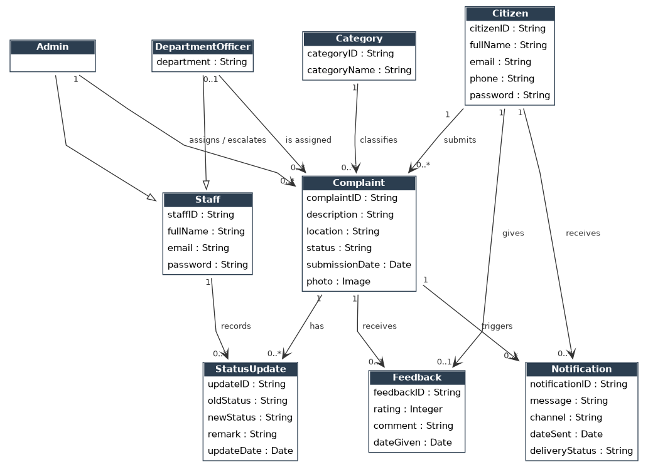
Domain Model of the Community Complaint Management System

2.5 Traceability to the SRS
The table below shows, for each domain class, which use cases and functional requirements from my previous SRS documentationn do its inclusion in the model. This is meant to show that every class in the diagram earns its place, rather than being added just because it seemed reasonable.
Domain Class | Related Use Cases / Functional Requirements
Citizen | UC-01 Register Account, UC-02 Login, UC-08 Update Profile - FR1, FR2, FR5
Staff (super-class) | UC-02 Login - FR4
Admin | UC-09, UC-12, UC-13, UC-14, UC-15, UC-16 - FR13, FR14
Department Officer | UC-10 View Assigned Complaints, UC-11 Resolve / Update Complaint - FR13, FR15, FR16
Complaint | UC-03, UC-04, UC-05, UC-09 - FR6, FR7, FR8, FR9, FR10, FR11
Category | UC-03 Submit Complaint, UC-13 Manage Categories - FR6
Status Update | UC-11 Resolve / Update Complaint - FR15, FR16
Notification | UC-17 Send Notification - FR12
Feedback | UC-06 Rate / Give Feedback

3. Data Flow Diagrams

3.1 What a Data Flow Diagram Shows
A Data Flow Diagram (DFD) shows how information moves around a system without describing the order in which things happen or the internaal logic of the code. Four symbols are used throughout this section: a rounded circle for a process that transforms or routes data, a rectangle for an external entity that sits outside the system boundary, an open-ended rectangle for a data store where information is kept, and a labelled arrow for a data flow betweeen any of these. The diagrams are drawn top-down, starting with a single Context Diagram (Level 0) and then breaking the one process in that diagram into snaller processes at Level 1, and finally breaking one Level 1 process further into Level 2.

3.2 External Entities and Data Stores
Four external entities sit outside the CCMS boundary and exchange data with it: Citizen, Department Officer, and Admin, who were all defined as actors in the SRS, plus an Email / SMS Gateway, which is the outside service the system uses to actually deliver a notification once it has been generated. Six data stores were identified from the information the use cases say the system must remember:
Data Store | Holds
D1 Citizens | Registered citizen accounts (name, email/phone, password, profile details).
D2 Complaints | Every complaint record, including its category, description, location, photo, status, and assignment.
D3 Categories | The list of complaint categories that Admin maintains and citizens choose from.
D4 Staff / Users | Login records for Department Officers and Admins issued by the system.
D5 Notifications | A log of every notification that has been generated, together with its delivery status.
D6 Feedback | The rating and comment left by a citizen against a resolved complaint.

3.3 Context Diagram (Level 0)
The Context Diagram treats the whole of CCMS as a single process and shows only the data that crosses the system boundary to or from each externeal entity. It is the starting point for the more detailed diagrams that follow, and it matches the use case diagram in the SRS in that the same four actors appear here as the parties the system exchanges data with.
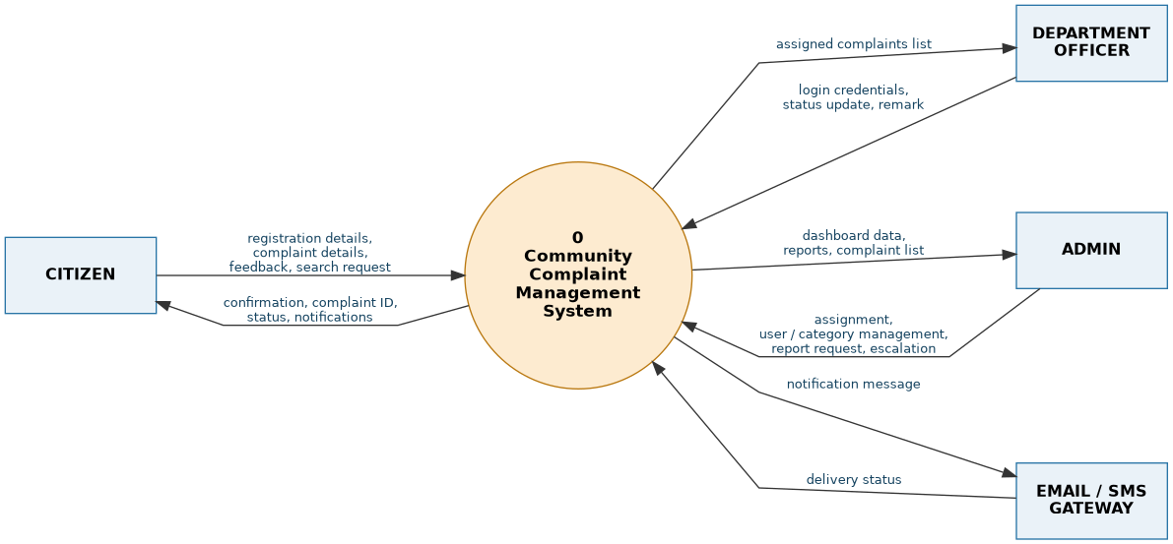
Context Diagram (Level 0) of CCMS

3.4 Level 1 Data Flow Diagram
At Level 1 the single CCMS process is broken down into the nine processes that carry out the functional requirements from the SRS: registration and login, submitting a complaint, tracking and viewing complaints, assigning a complaint, resolving or updating a complaint, managing users and categories, generating reports, sending a notification, and giving feedback. Each process reads from or writes to one of the six data stores identified above, and the diagram shows exactly where each external entity's data enters or leaves the system.

Level 1 Data Flow Diagram of CCMS
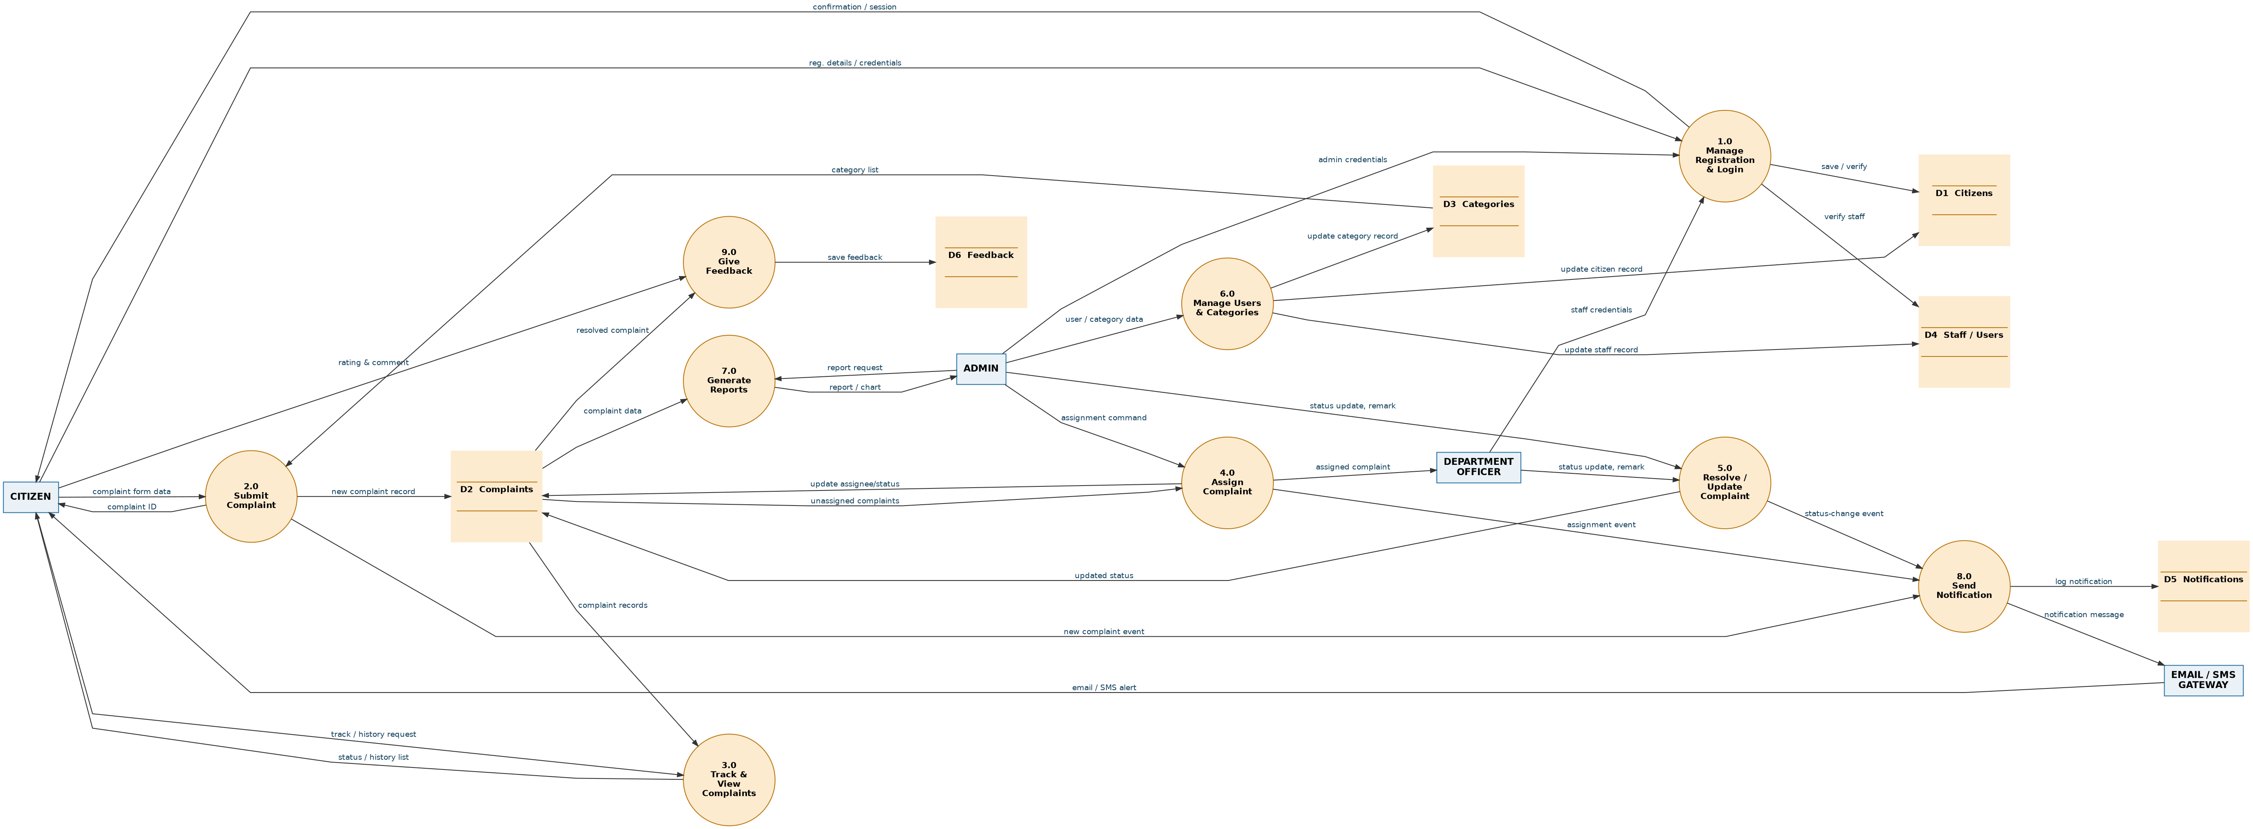
Level 1 Data Flow Diagram of CCMS

3.5 Level 2 Data Flow Diagram - Submit Complaint (Process 2.0)
Process 2.0 (Submit Complaint) was chosen for a further breakdown because it is the process that creates the central record of the whole system, the complaint itself, and it involves more than one internal step: the form has to be checked, a unique complaint ID has to be produced, the record has to be saved, and Admin has to be told that a new complaint is waiting to be assigned. Breaking it down this way keeps each Level 2 process doing one clear job.
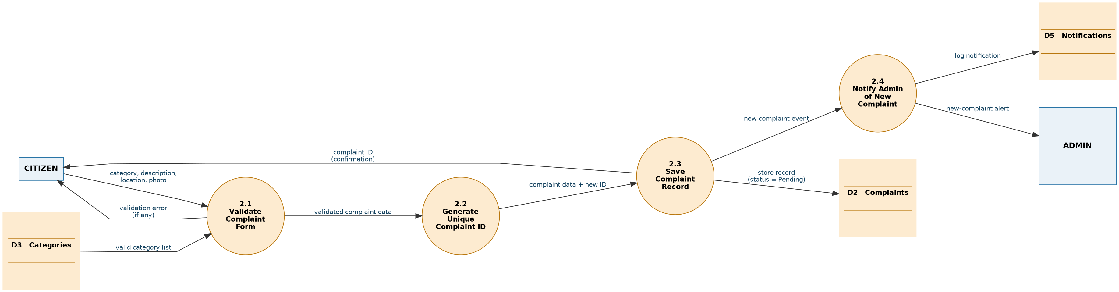
Level 2 Data Flow Diagram of Process 2.0 (Submit Complaint)

3.6 Data Dictionary
The table below briefly defines the more important data flows named in the diagrams of this section, so that a reader does not have to guess what a label like "assignment command" is meant to carry.
Data Flow | Description
Registration details | Name, email or phone number, and password entered by a citizen when creating an account (FR1).
Complaint form data | Category, description, location, and optional photo entered when filing a new complaint (FR6, FR7).
Complaint ID | The unique identifier the system automatically generates for every new complaint (FR8).
Status | The current state of a complaint: Pending, In Progress, or Resolved (FR9).
Status update / remark | The new status and optional short note added by staff when a complaint is worked on (FR15, FR16).
Assignment command | Admin's instruction linking a complaint to a specific department officer (UC-09).
Notification message | The short automatic message delivered to a citizen when their complaint changes (FR12).
Rating & comment | The satisfaction score and optional written feedback left once a complaint is Resolved (UC-06).
Report request | Admin's choice of which summary to generate, such as complaints by category or by area (UC-14).
Search / filter request | Keywords or filter values, such as category, area, or status, used to narrow a complaint list (FR17, FR18).
User / category data | Details Admin enters when creating, editing, or removing a user account or a complaint category (UC-12, UC-13).
Delivery status | Confirmation from the Email / SMS Gateway that a notification was, or was not, delivered (UC-17 alternate flow).

4. System Sequence Diagrams

4.1 What a System Sequence Diagram Shows
A System Sequence Diagram (SSD) is a simplified sequence diagram that has exactly two lifelines: the actor who is carrying out a use case, and the system itself, treated as a single black box. It shows, in order from top to bottom, every message the actor sends to the system and every value the system returns, without showing anything about how the system produces that response internally. An SSD is useful at the analysis stage because it fixes the input and output of a use case before any decision is made about which internal class or component will actually handle each message. Nine use cases from the SRS were chosen for this section, so that every actor and every major module of CCMS - registration, complaint handling, assignment, resolution, reporting, and category management - is represented by at least one diagram.

4.2 SSD - Register Account (UC-01)
This diagram covers a citizen creating a new account, matching the main flow of UC-01 in the SRS. The citizen opens the registration page, is shown the registration form, fills it in and submits it, and the system confirms that the account has been created.
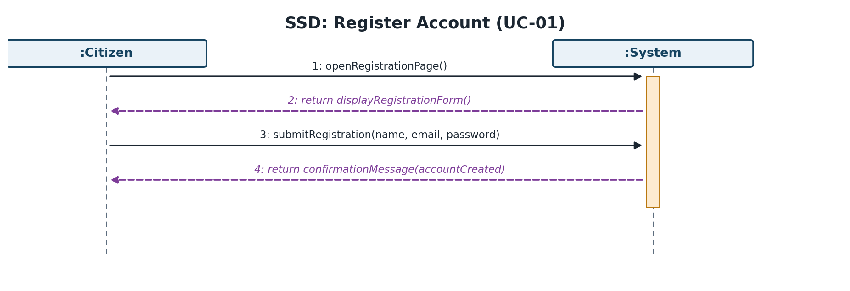
Figure 4.2 - System Sequence Diagram for Register Account

4.3 SSD - Login (UC-02)
This diagram covers a user, whether citizen, department officer, or admin, logging into the system, matching UC-02. The user picks their role and enters their credentials, and the system authenticates them and sends them to the dashboard that matches their role.
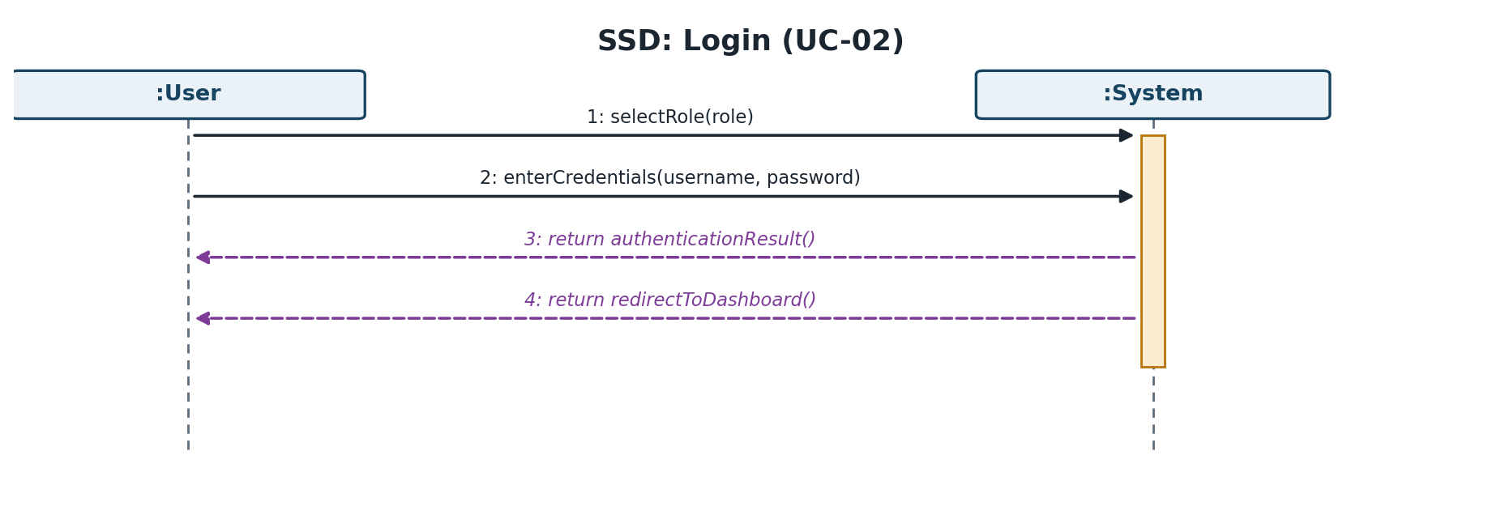
System Sequence Diagram for Login

4.4 SSD - Submit Complaint (UC-03)
This diagram covers a citizen filing a new complaint, matching UC-03. The citizen asks to start a new complaint, is shown the complaint form together with the list of categories, fills it in and submits it, and the system responds with the newly generated complaint ID that the citizen can use later to track the complaint.
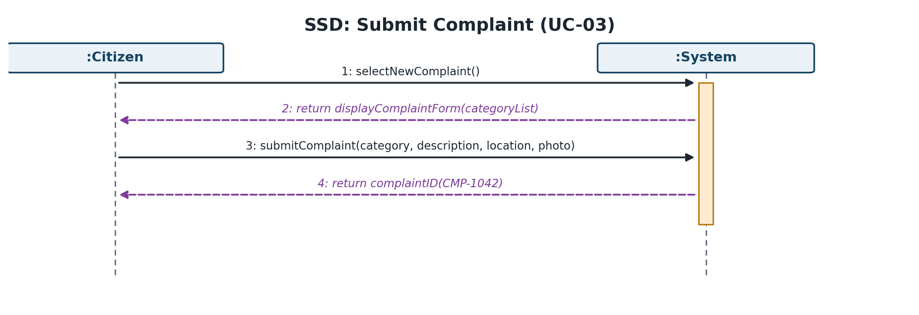
System Sequence Diagram for Submit Complaint

4.5 SSD - Track Complaint Status (UC-04)
This diagram covers a citizen checking on a complaint that was submitted earlier, matching UC-04. The citizen opens the tracking page and requests the status using the complaint ID, and the system returns the current status together with any remark that a department officer has added.
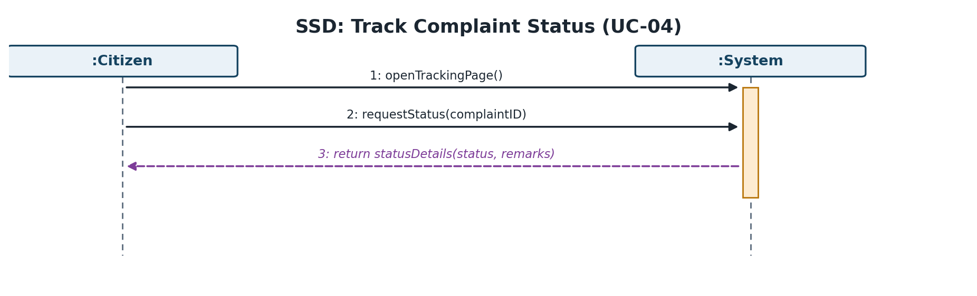
System Sequence Diagram for Track Complaint Status

4.6 SSD - Assign Complaint (UC-09)
This diagram covers Admin assigning a newly submitted complaint to a department officer, matching UC-09. Admin first views the list of unassigned complaints, then assigns the chosen complaint to an officer, and the system confirms that the assignment has been made and that the complaint status has moved to In Progress.
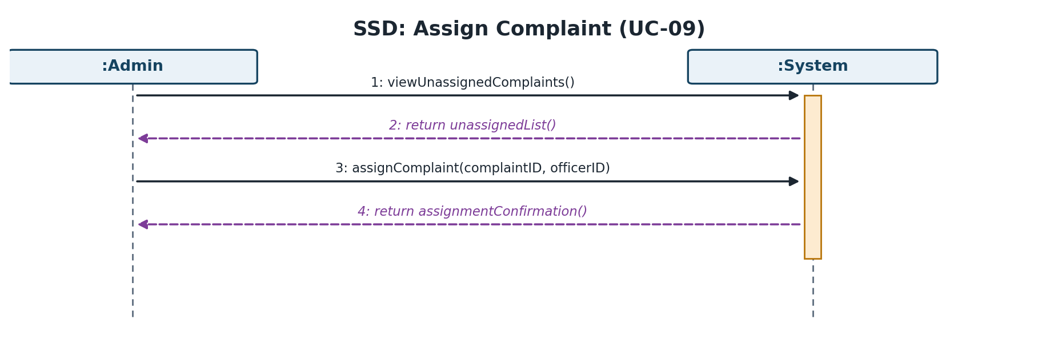

4.7 SSD - Resolve / Update Complaint (UC-11)
This diagram covers a department officer working on a complaint that has been assigned to them, matching UC-11. The officer opens the assigned complaint, reviews its details, then updates its status and adds a remark, and the system confirms that the update has been saved and that the citizen has been notified.
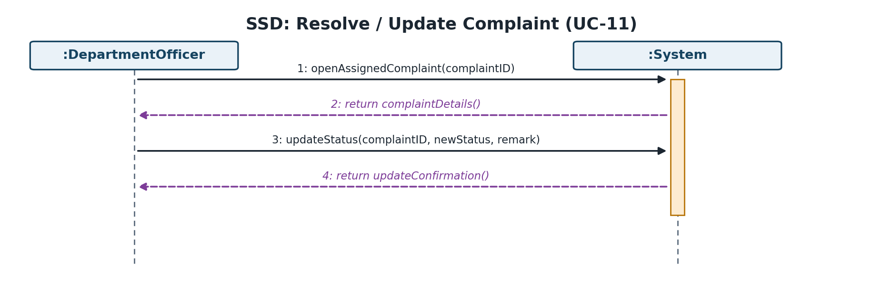

4.8 SSD - View Complaint History (UC-05)
This diagram covers a citizen looking back over everything they have submitted, matching UC-05. The citizen opens their complaint history, the system returns the full list, and the citizen can select any one entry to see its full details.
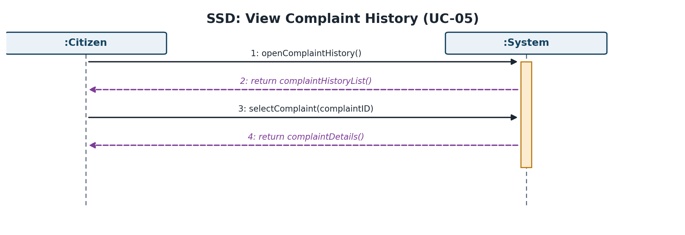
Figure 4.8 - System Sequence Diagram for View Complaint History

4.9 SSD - Generate Reports (UC-14)
This diagram covers Admin producing a summary of complaint activity, matching UC-14. Admin opens the reports section and chooses the type of report needed, such as complaints by category or by area, and the system returns the compiled chart.
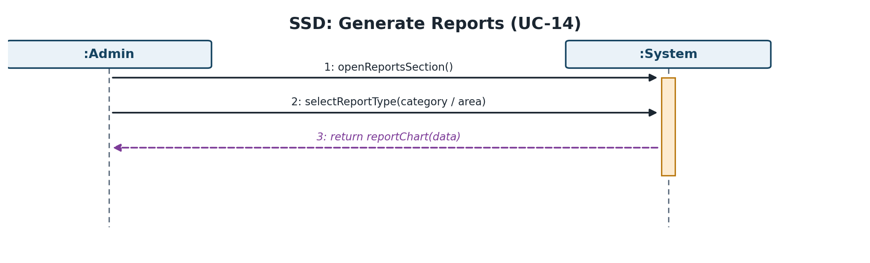

4.10 SSD - Manage Categories (UC-13)
This diagram covers Admin maintaining the list of complaint categories, matching UC-13. Admin opens the category management screen, is shown the existing categories, adds or edits one, and the system returns the updated list that citizens will see the next time they submit a complaint.
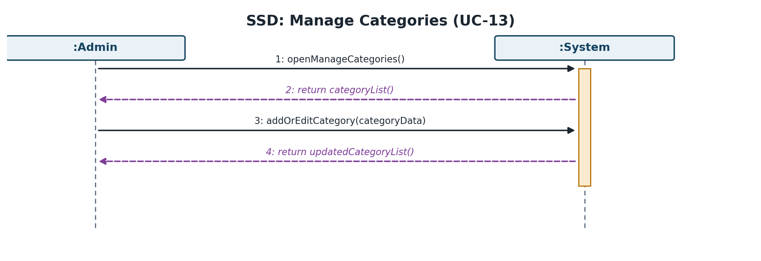

5. Conclusion
This document has presented the three analysis models required for Assignment 3 of the Community Complaint Management System project. The Domain Model identified the real-world classes the system needs to remember and the relationships between them, and traced each class back to the use cases and functional requirements that justify it. The Data Flow Diagrams, drawn at the Context, Level 1, and Level 2, showed how data moves between the actors, the internal processes, and the data sores of the system, and the accompanying data dictionary defined the more important data flows in plain language. The System Seqence Diagrams showed the exact order of messages exchanged between an actor and the system for nine of the more important use cases, covering all four actors defined in the SRS.
Taken together, these three models give a consistent and complete picture of the CCMS problem space that stays true to the functional requirements and use cases already agreed in the SRS. They are intended to be used directly as the starting point for the design phase of the project, where the prcesses identified in the DFDs and the messages identified in the SSDs will be mapped ont actual system classes, and the domain model will be refined into a design class diagram.

COMMUNITY COMPLAINT MANAGEMENT SYSTEM
Design Documentation
Architectural Design | Class Diagram | Activity Diagrams | Interaction Diagrams | Interface Design
Submitted By: Shahzaib Khan
Submitted To: Dr. Umer Rashid
Course: Analysis and Design of Software Systems (CS-222)
Assignment 4 — Design Documents

Table of Contents
1. Introduction 3
1.1 Purpose of this Document 3
1.2 Scope 3
1.3 How this Document is Organised 3
2. Software Architecture Design 3
2.1 What Architectural Design Represents 3
2.2 Architectural Style Selected 4
2.3 Layer Responsibilities 4
2.4 Architecture Diagram 4
2.5 Traceability to the Domain Model 5
3. Class Diagram 6
3.1 What a Design Class Diagram Shows 6
3.2 From Domain Model to Design Classes 6
3.3 Design Classes and Responsibilities 6
3.4 Class Diagram 7
3.5 GRASP Patterns Applied 9
4. Activity Diagrams 10
4.1 What an Activity Diagram Shows 10
4.2 Activity Diagram — Register Account & Login 10
4.3 Activity Diagram — Submit Complaint 11
4.4 Activity Diagram — Assign Complaint 11
4.5 Activity Diagram — Resolve / Update Complaint 12
5. Interaction (Sequence) Diagrams 14
5.1 What an Interaction Diagram Shows 14
5.2 Sequence Diagram — Register Account 14
5.3 Sequence Diagram — Submit Complaint 16
5.4 Sequence Diagram — Assign Complaint 18
5.5 Sequence Diagram — Resolve / Update Complaint 20
6. Interface Design 23
6.1 Design Principles 23
6.2 Login / Registration Screen 23
6.3 Citizen Dashboard 24
6.4 Admin Dashboard 24
6.5 Department Officer Panel 25
6.6 Navigation Map 26
7. Conclusion 28
References 28

1. Introduction

1.1 Purpose of this Document
My this document is related to the Design submission for the Community Complaint Management System (CCMS) project. It is builids directly on the Analysis Documentation submitted for Assignment 3, taking the Domain Model, the Data Flow Diagrams, and the System Sequence Diagrams produced there and convert these into a set of design-level artefacts. The analysis stage deliberately avoided any decision about how the system would actually be built; this document makes exactly those decisions — how the system is organised into layers, which classes exist and what operations they expose, how objects collaborate to carry out each use casae, and what the citizan, admin, and department officer actually see on the screen. The models presented here are detailed enough that a programer could begin writing code directly from them.

1.2 Scope
This document covers the same four actors and the same use cases defined in the SRS in my (Assignmentno 2) and carried through the Analysis Documentation in my (Assignmentno 3): Citizen, Department Officer, Admin, and the System acting as an automatic Notifier. In this assignment five design artifacts are briefly explained that helps to create the system design interface.
- In the layer Architecture Diagram, showing the layered structure of the software system and the responsibility of each layer.
- A Design Class Diagram, extends the Domain Model and it includes attributes , with operations, a controller class, and the GRASP patterns used to assign the responsibilities.
- A Activity Diagrams for the four workflows that make up the core lifecycle of a complaint: registering and logging in, submitting a complaint, assigning a complaint, and resolving / updating a complaint.
- Interaction (Sequence) Diagrams for the same four workflows, that is showing the exact objects involved and the order in which they exchange messages.
- Interface Design that is the mockups for the main screens used by each actor in my software design, together with a navigation map showing how the each screens connect with the each oters.

1.3 How this Document is Organised
This my design docunments assignmet Section 2 presents the software architecture design . Section 3 presents/represents the design class diagram. Section 4 presents/represents the four activity diagrams. Section 5 presents the four interaction (sequence) diagrams. Section 6 presents the interface design and the navigation map. Section 7 closes the document with a short summary of how the design fits together and what is left for the next phase of the implementation and testing phase.

2. Software Architecture Design

2.1 What Architectural Design
Architectural design is concerned and represented with the large building blocks of a software system rather than individual classes: how the system is divided into layers or components, what is the functionality of eachs , what each one is responsible for, and how they are alowed to talk to one another. Deciding this early keeps the rest of the design consistent..

2.2 Architectural Style Selected
In my project A layered (N-tier) architecture I chosen for CCMS. In a layered architecture the system is divided into horizontal layers stacked on top of one another, and a layer is only allowed to call the layer directly beneath it. This keeps the presentation code, the business rules, and the database access separate, which makes the system easier to test, easier to change — a new front end could be added later without touching the business logic — and easier for two students to divide the work on, which matches how this project was actually built. Below table compares the layered style against two alternatives that were considered.
Table : Architectural Style Comparison
Architectural Style | Suitability for CCMS | Decision
Layered (N-Tier) | Clear separation between UI, business rules, and data; matches a moderate-sized web system built around one database; easy to divide work between two developers.i select that | Selected

2.3 Layer Responsibilities
Below ists the four layers identified for CCMS, what each is responsible for, and the components placed in it.
Table : Layer Responsibilities
Layer | Responsibility | Example Components
Presentation | This layer Displays screens to the citizen, admin, and department officer, and collects their input. Contains no business rules of its own. | Citizen Web Portal, Admin Panel, Department Officer Panel
Application | Receives requests from the presentation layer, applies the business rules, and coordinates the domain objects needed to satisfy each use case. | AuthController, ComplaintController, AssignmentController, ComplaintUpdateCtrl, ReportService, NotificationService
Data Access | Translates between domain objects and rows in the database. The only layer that is aware SQL exists. | CitizenRepository, ComplaintRepository, CategoryRepository, StaffRepository, NotificationRepository, FeedbackRepository
Data | Stores the data persistently. | CCMS Database (relational)
An external service — an Email/SMS gateway — sits outside the four layers and is only ever reached through NotificationService, so a different provider could be substituted without changing any other part of the system.

2.4 Architecture Diagram
This architecture diagram shows the four layers and also the external notification service which is external to the architecture layr, together with the components identified for each layer and the direction requests and responses flow between all the adjacent layers.
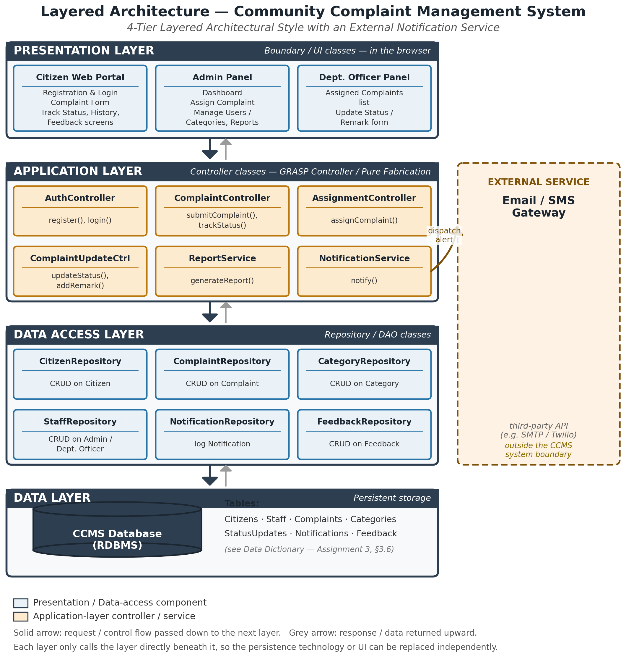
Figure 2.1 — Layered Architecture of the Community Complaint Management System

Every component in the Application and Data Access layers exists to support one or more of the domain classes identified in the Domain Model (Assignment 3, Section 2). ComplaintController and ComplaintRepository exist because Complaint is the central class of the system; AuthController exists to support Citizen and Staff login; NotificationService exists to support the Notification class. ReportService is new at the design stage — it was not a domain class, because generating a report is a system responsibility rather than a real-world concept a citizen or officer would recognise.

3. Class Diagram

3.1 What a Design Class Diagram Shows

A class diagram is a blueprint of a software systemc that shows what classes exist, what information they store like their attributes and details , what functions they perform like operations , and how they are connected.I t also include association , aggregation and composition relationship and also multiplicity.

3.2 From Domain Model to Design Classes
The nine domain classes has been identified in my Assignment 3 — Citizen, Staff, Admin, Department Officer, Complaint, Category, Status Update, Notification, and Feedback — are carried forward unchanged in terms of their attributes and relationshiops. What changes at the design stage is that each class is now given the operations it needs to fulfil its responsibilities, and one new class, ComplaintController, is introduced to coordinate the others.

3.3 Design Classes and Responsibilities
Bwlow Table 3.1 lists every class in the design, and also its stereotype, and its main responsibilitywhat is the functionality of that class means .
Table 3.1 — Design Classes and Responsibilities
Class | Stereotype | Key Responsibility
ComplaintController | «control» | Receives requests from the boundary (UI) layer and it also coordinates the domain objects needed to carry them out.
Citizen | «entity» | Holds a citizen's account details; submits complaints, tracks their status , and citizen can also gives the feedback.
Staff (abstract) | «entity» | Holds the login details that are shared by Admins and Department Officers.
Admin | «entity» | Assigns and escaltes complaints mean update the old one complaint , manages users and categories, and also generates the reports.
Department Officer | «entity» | Views and updates the complaints assigned to their department abd then resolved it .
Complaint | «entity» | The central record of a single reported problem and its current status.e.g, street light, road etc.
Category | «entity» | A classification a citizen chooses when filing a complaint.
Status Update | «entity» | A record of one change in a complaint's status.
Notification | «entity» | A message sent to a citizen about their complaint that was submitted earler .
Feedback | «entity» | The giving of rating and comment a citizen leaves once a complaint is resolved.Citizen share their opinion about this.

3.4 Class Diagram
Below Figure 3.1 shows the full design class diagram, including the attributes, the operations, and the relationships (with multiplicities) between all the ten classes.
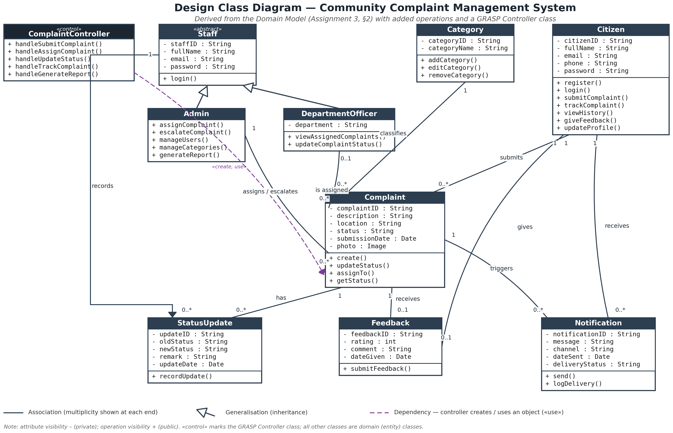

3.5 GRASP Patterns Applied
Table 3.2 explains where each of the four GRASP patterns used in this design is applied, and why.
Table 3.2 — GRASP Patterns Applied
Pattern | Where It Is Applied | Reasoning
Controller | ComplaintController sits between the boundary classes and the domain classes. | Keeps the boundary (UI) classes free of business logic and gives every use case a single, testable entry point.
Creator | ComplaintController creates Complaint and Status Update objects; AuthController creates Citizen objects. | The controller holds the data (from the submitted form) needed to initialise the new object — Larman's Creator condition.
Information Expert | Complaint updates its own status and officer link (updateStatus(), assignTo()) rather than the controller changing it directly. | Complaint have the information complete that it holds , needed to carry out the operation, so it should be the one to do it.
Pure Fabrication | NotificationService and ReportService. | The Sending of alert or buils a report is a technical responsibility with no natural counterpart in the domain model, so it is placed in fabricated class rather than the forced onto Complant or Citizen.

4. Activity Diagrams

4.1 What an Activity Diagram Shows
An activity diagram shows the flow of control through a use case. the individual actions that are carried out, the order they happen in, and the points where the flow branches depending on a condition. Unlike a sequence diagram, it does not show which object is responsible for each action and what is the responsibility of each objct,it show only which actor or which part of the system (shown as a swimlane) carries it out. The four diagrams in this section correspnd to the four activities that make up the core lifecycle of a complaint in CCMS: registering and logging in, submitting a complaint, assigning a complaint, and resolving or updating a complaint.

4.2 Activity Diagram :: Register Account & Login (UC-01, UC-02)
This diagram covers both UC-01 of the (Register Account) and UC-02 which is (Login), since login is reused immediately after registration and by every other actor signing in. Two swimlanes are used — Citizen and System — and each branch that can fail loops back to give the citizen another attempt rather than ending the use case.
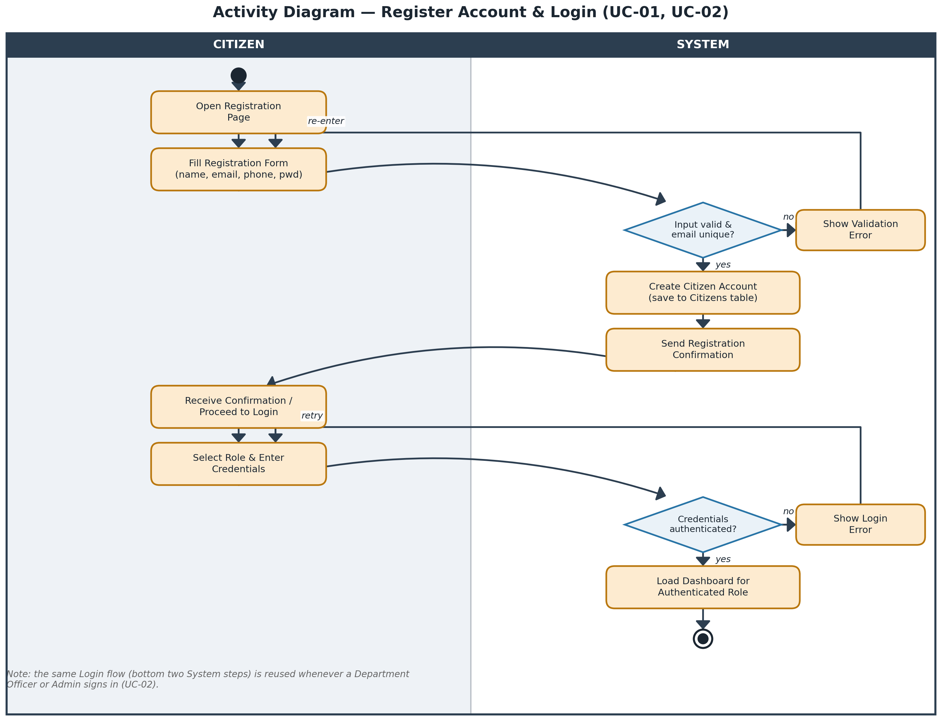
Activity Diagram for Register Account & Login
Table 4.1 — Register & Login Decision Points
Decision Point | Outcome
Input valid & email unique? — yes | Citizen account is created, a confirmation is sent, and the citizen proceeds to log in.
Input valid & email unique? — no | A validation error is shown and the citizen re-enters the registration form.
Credentials authenticated? — yes | The dashboard for the authenticated role (Citizen, Admin, or Department Officer) is loaded.
Credentials authenticated? — no | A login error is shown and the citizen retries.

4.3 Activity Diagram — Submit Complaint (UC-03)
This diagram assumes the citizen is already logged in. It follows the complaint from the moment the citizen opens the form through to the confirmation screen, including the validation loop that keeps the citizen on the form until every required field is complete.
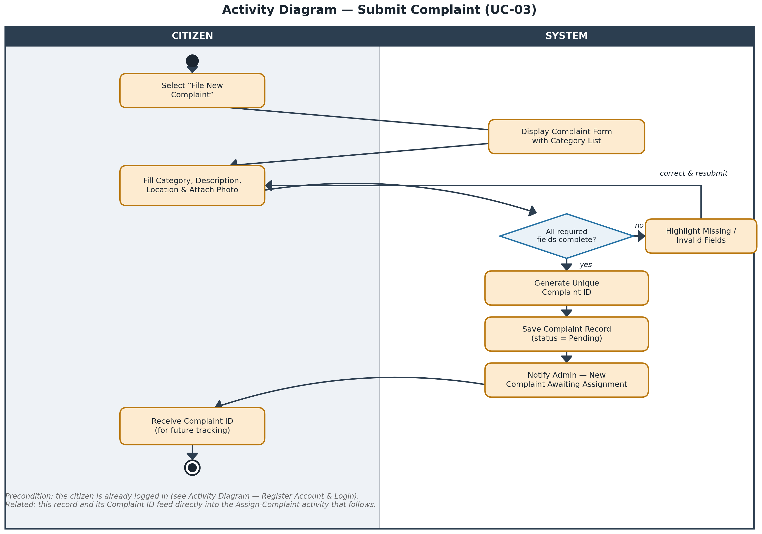
Activity Diagram for Submit Complaint
Table 4.2 — Submit Complaint Decision Point
Decision Point | Outcome
All required fields complete? — yes | A unique Complaint ID is generated, the record is saved with status Pending, and Admin is notified that a new complaint is waiting.
All required fields complete? — no | The missing or invalid fields are highlighted and the citizen corrects and resubmits the form.

4.4 Activity Diagram — Assign Complaint (UC-09)
This diagram extends the UC-09 with the SLA-escalation check that is part of Admin's escalation responsibility identified in the Domain Model (Assignment 3). Before Admin chooses a complaint to assign, the system checks whether any complaint in the unassigned list has been waiting longer than the SLA threshold and that was not resolved and, if so, flags gives these complaint as high priority so Admin can see it and gave and needs attention first to it so these complaints can easily be resolved .
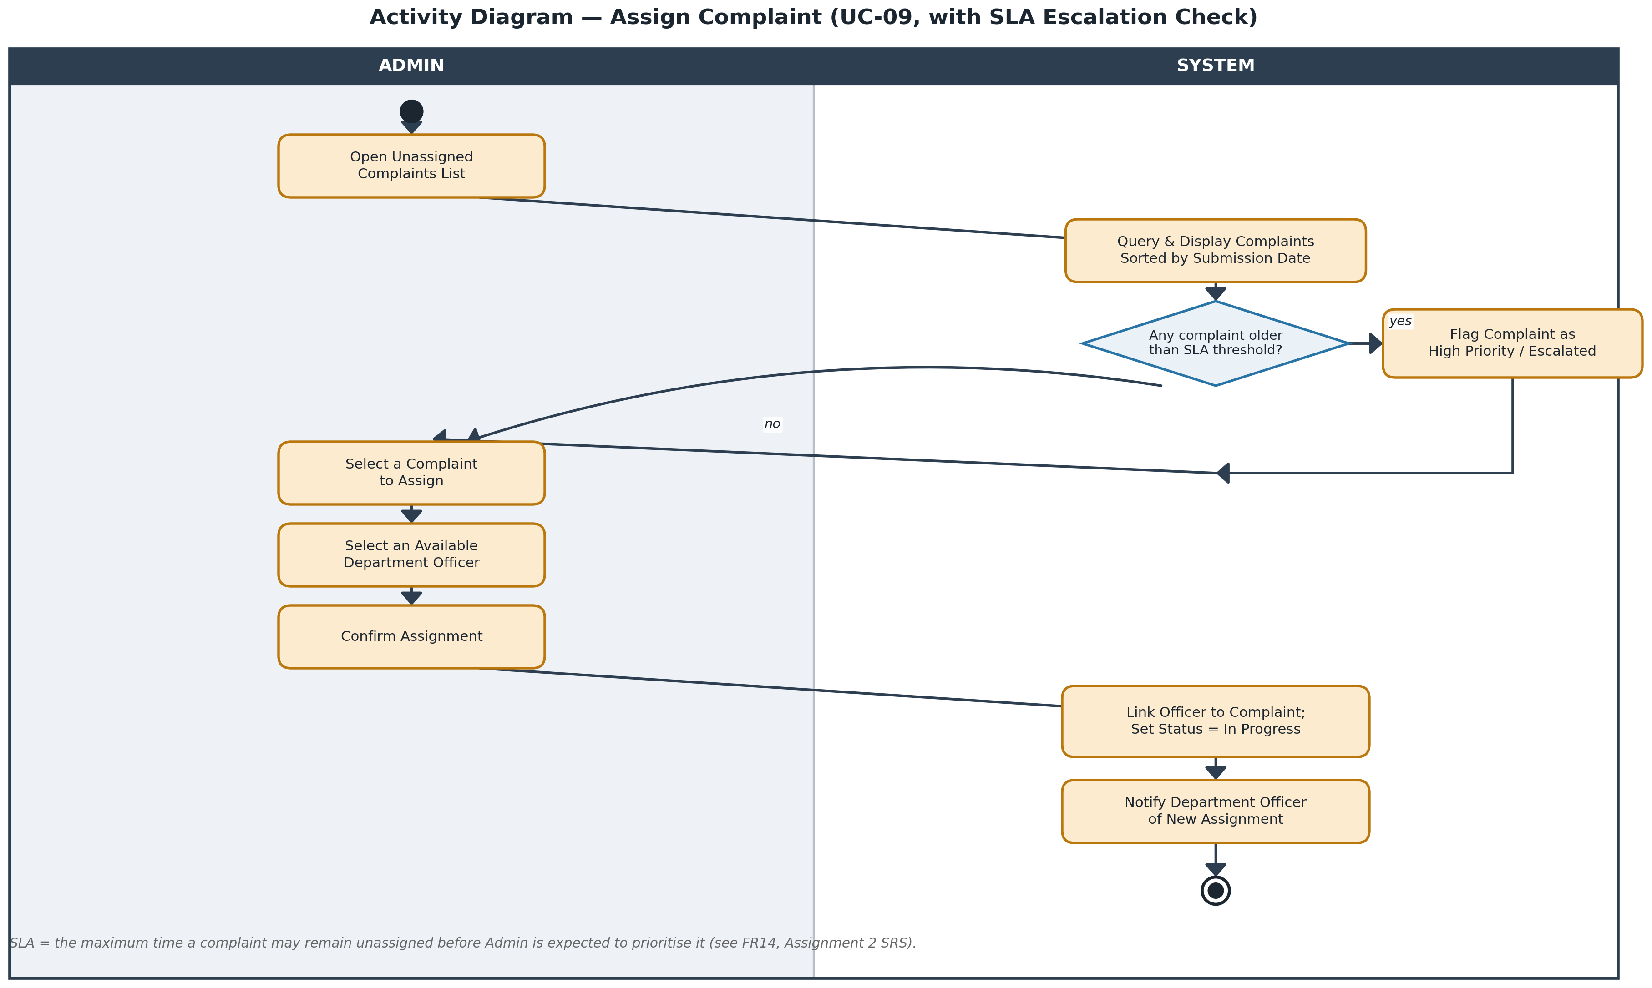
Activity Diagram for Assign Complaint, with SLA Escalation Check
Table 4.3 — Assign Complaint Decision Point
Decision Point | Outcome
Any complaint older than SLA threshold? — yes | The complaint is flagged High Priority / Escalated before Admin selects a complaint to assign.
Any complaint older than SLA threshold? — no | Admin proceeds directly to selecting a complaint to assign.

4.5 Activity Diagram — Resolve / Update Complaint & Notify Citizen (UC-11)
This diagram covers a Department Officer updating the status of a complaint assigned to them by pending/ in progress / resolved so these all are managed by the department officer . Both branches of the final decision update the citizen-facing Track Complaint screen; a complaint marked Resolved additionally prompts to the citizen for feedback citizen share their feedback details and share their thoughts how much the citizen is satisfied by it , linking this activity forward to UC-06 (Give Feedback).
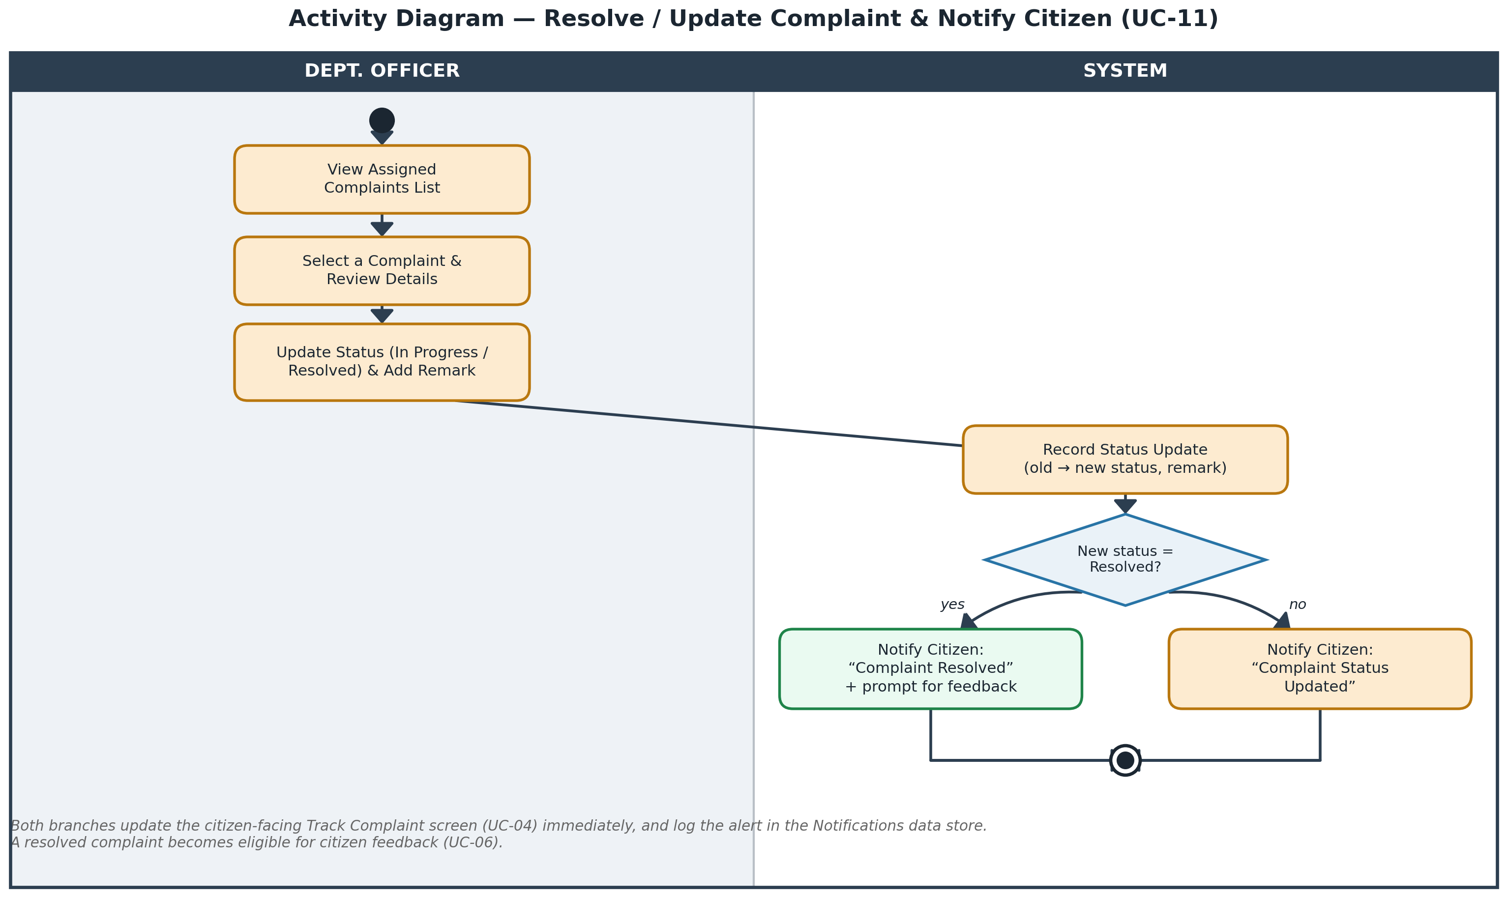
Figure 4.4 — Activity Diagram for Resolve / Update Complaint & Notify Citizen
Table 4.4 — Resolve / Update Decision Point
Decision Point | Outcome
New status = Resolved? — yes | The citizen is notify by the this message that the “Complaint Resolved” and prompted to leave feedback.
New status = Resolved?-- no | The citizen is notified that their complaint's status has been updated if it already not resolved so it show that message.

5. Interaction (Sequence) Diagrams

5.1 What an Interaction Diagram Shows
Where an activity diagram shows the flow of control, an interaction (sequence) diagram shows the flow of messages between specific objects, arrnged in the order they happen means message order will be kept in interaction sequence , with a lifeline for every object involved and an activation bar showing when each object in a system is doing work and when not . The four sequence diagrams in this section extend the System Sequence Diagrams produced in last analysis documents section by replacing the single “:System” lifeline with the actual boundary, control, entity, and repository objects that carry out each use case.

5.2 Sequence Diagram — Register Account (UC-01)
This diagram elaborates the System Sequence Diagram for Register Account (Assignment 3, Figure 4.2) into a full object collaboration. AuthController checks that the e-mail address is not already registered before creating the new Citizen object, applying the Creator pattern.
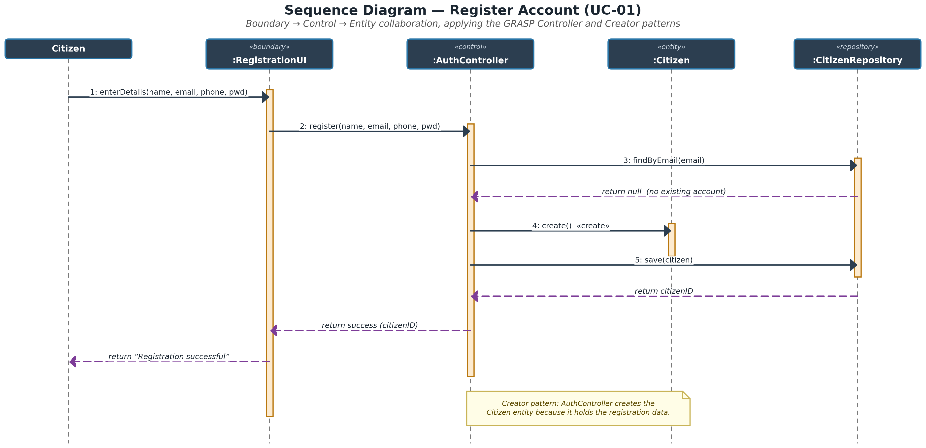
Figure 5.1 — Sequence Diagram for Register Account
Table 5.1 — Register Account Message Steps
Step | Message | Purpose
1 | enterDetails(name, email, phone, pwd) | Citizen submits the registration form.
2 | register(name, email, phone, pwd) | The boundary forwards the request to the controller.
3 | findByEmail(email) | The controller checks the e-mail address is not already registered.
4 | create() | The controller creates the new Citizen object (Creator pattern).
5 | save(citizen) | The new citizen record is persisted through the repository.

5.3 Sequence Diagram — Submit Complaint (UC-03)
This diagram elaborates the System Sequence Diagram for SubmitComplaint (Assignment 3) . After the Complaint object is created and saved, ComplaintController delegates the admin alert to NotificationService rather than sending it directly, keeping the notification mechanism in one place (Pure Fabrication).
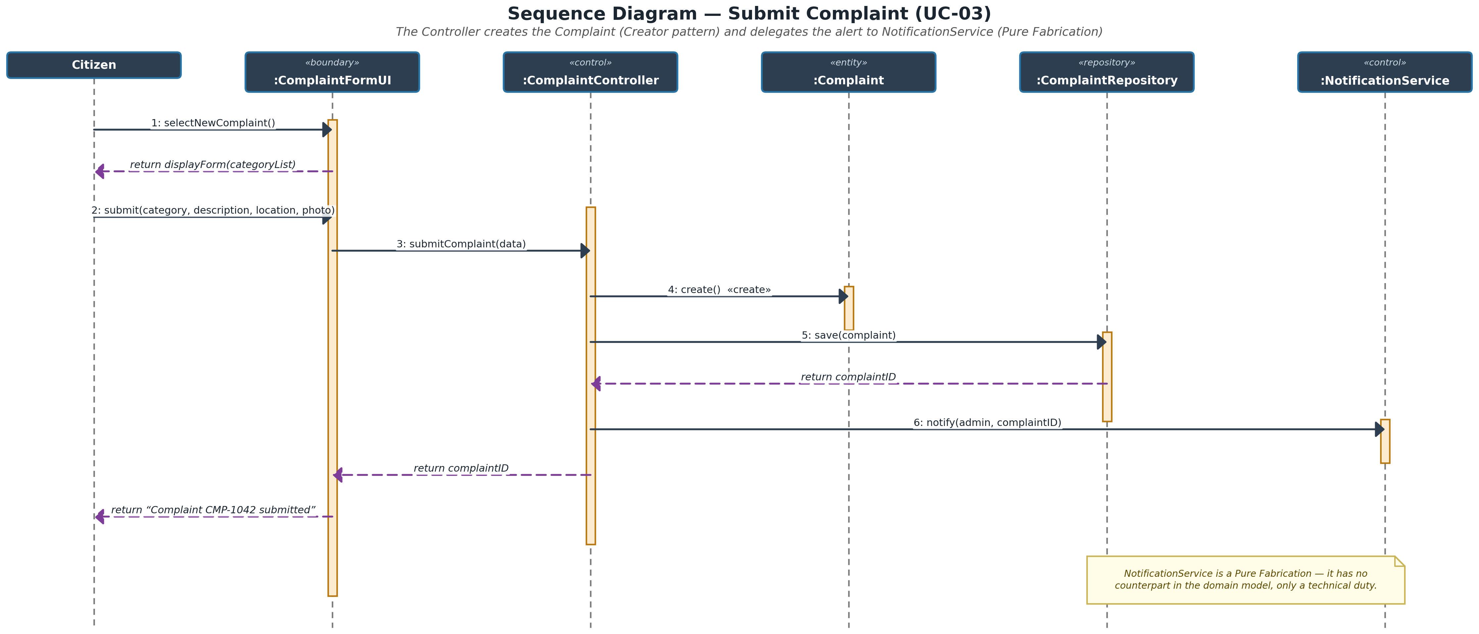
Figure 5.2 — Sequence Diagram for Submit Complaint
Table 5.2 — Submit Complaint Message Steps
Step | Message | Purpose
1–2 | selectNewComplaint() / displayForm(categoryList) | The citizan opens the complaint form and the system returns the category list.
3 | submitComaplaint(data) | The filled-in form is forwrarded to ComplaintController.
4 | create() | The controller creates the new Complaint object (Creator pattern).
5 | save(complaint) | The complaint is persisted and a Complaint ID is generated.
6 | notify(admin, complaintID) | NotificationService alerts Admin that a new complaint is waiting.

5.4 Sequence Diagram — Assign Complaint (UC-09)
This diagram elaborates the System Sequence Diagram for Assign Complaint (Assignment 3). Steps 6 and 7 apply the Information Expert pattern: the Complaint object updates its own officer link and status because it is the object that holds that data.
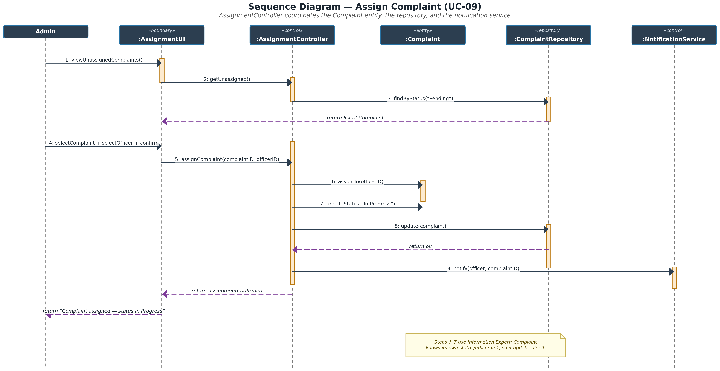
Figure 5.3 — Sequence Diagram for Assign Complaint
Table 5.3 — Assign Complaint Message Steps
Step | Message | Purpose
1–4 | viewUnassignedComplaints() … return list | Admin requests and receives the list of unassigned complaints.
5 | assignComplaint(complaintID, officerID) | Admin's selection and confirmation are forwarded to AssignmentController.
6–7 | assignTo(officerID) / updateStatus(“In Progress”) | The Complaint object updates its own officer link and status (Information Expert).
8 | update(complaint) | The change is persisted through ComplaintRepository.
9 | notify(officer, complaintID) | NotificationService alerts the Department Officer of the new assignment or the complaint.

5.5 Sequence Diagram — Resolve / Update Complaint (UC-11)
This diagram elaborates the System Sequence Diagram for Resolve / Update Complaint (Assignment 3). ComplaintUpdateCtrl creates a new Status Update record for every change Creator pattern before the citizen is notified, so a ful history of status changes is always available for the Track Complaint and Complaint History screens.
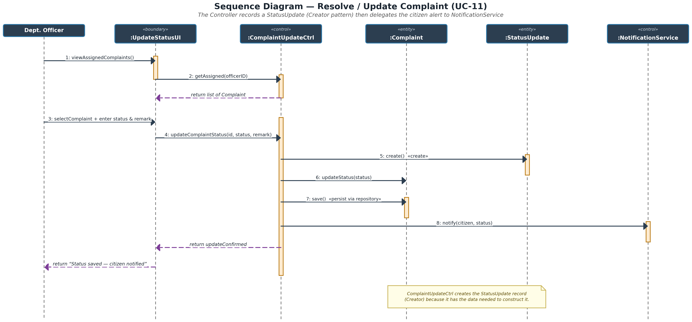
Figure 5.4 — Sequence Diagram for Resolve / Update Complaint
Table 5.4 — Resolve / Update Message Steps
Step | Message | Purpose
1–3 | viewAssignedComplaints() … return list | The officer requests and then after receives their assigned complaints which the officer requests for.
4 | updateComplaintStatus(id, status, remark) | The officer's chosen status and remark are forwarded it to the controler.
5 | create() | The controller function is to creates a new Status Update record (Creator pattern).
6–7 | updateStatus(status) / save() | The Complaint object function is to records its new status and the change is peristed.
8 | notify(citizen, status) | NotificationService function is to alerts the citizen of the status change.

6. Interface Design

6.1 Design Principles
The interface design that is mockups in this section follow the five rule/ principles, that I mentioned in the table . that were applied consistently across every screen in my software system.
Table 6.1 — Interface Design Principles
Principle | How It Is Applied
Consistent branding | The navy-and-gold colour palette carried over from the SRS, the Analysis Documentation, and the project presentation is used on every screen, with the CCMS wordmark in the same position throughout.
Role-based navigation | Each actor sees only the navigation links relevant to their role — for example, Manage Categories only appears for Admin.
Status colour-coding | Gold = Pending, Blue = In Progress, Green = Resolved, used consistently across every screen and matching the Complaint.status values defined in the Class Diagram (Section 3.4).
Minimal steps | A citizen can submit a complaint in three steps (select, fill, submit) , an officer can update a status in two (select ; update).
Accessibility | Status is always shown as coloured text plus a label, never colour alone, and every input field has a visible text label rather than relying only on placeholder text.

6.2 Login / Registration Screen
This is the single entry point for all three actors that use the system. The Role field determines which dashboard the citizen, admin, or officer is taken to after a successful login and all the dashboard for three ator have a separate interface design, and the same screen hosts the registration form for new citizens behind the Register tab.
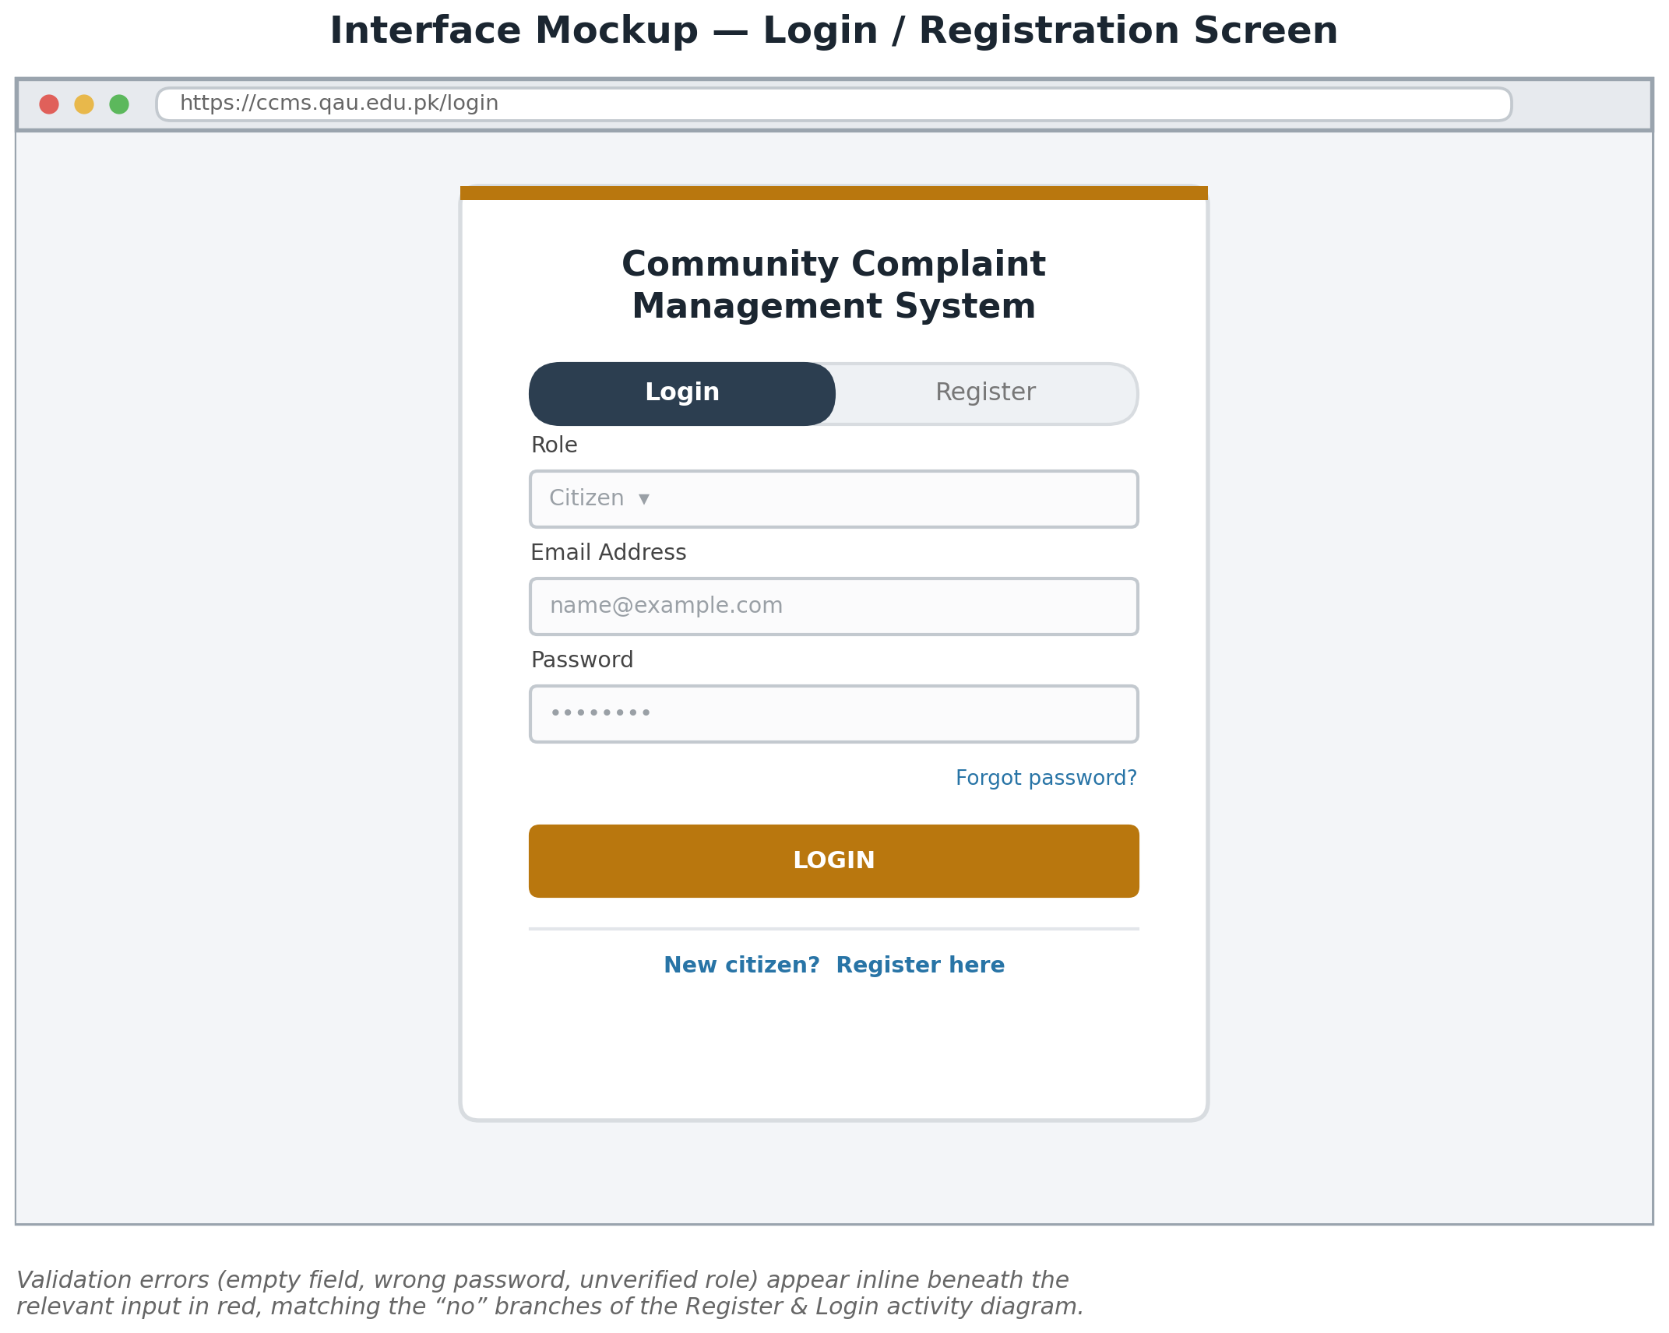
Figure — Login / Registration Screen

6.3 Citizen Dashboard
This citizen dashboard opens on a summary of the citizen's own complaints, with colour-coded status, and a shortcut to file a new complaint. This screen is the destination of the “Load Dashboard” step in the Register & Login activity diagram for a citizen.
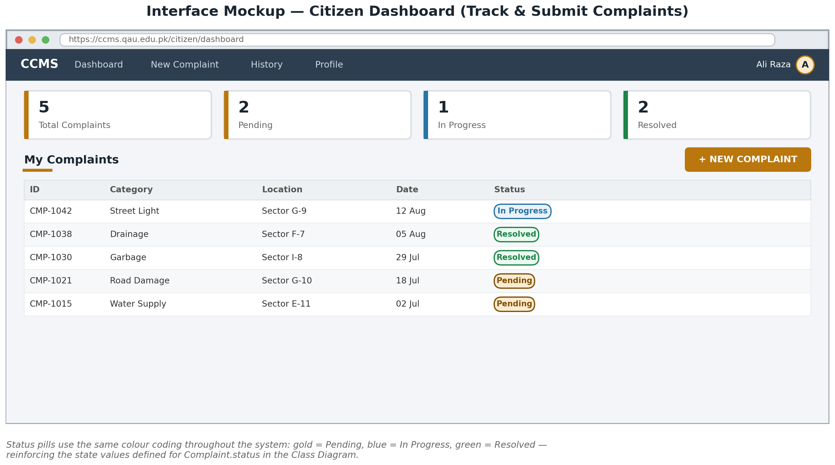
Figure — Citizen Dashboard

6.4 Admin Dashboard
The admin dashboard has been lists unasigned complaints sorted by submission date, with overdue complaints flagged in red — the same flag produced by the SLA-escalation check in the Asign Complaint activity diagram . Admin assigns a complaint to a any of the department officer directly from this table.this is main interface of the admin that admin use to assign any complaint to their relative departments .
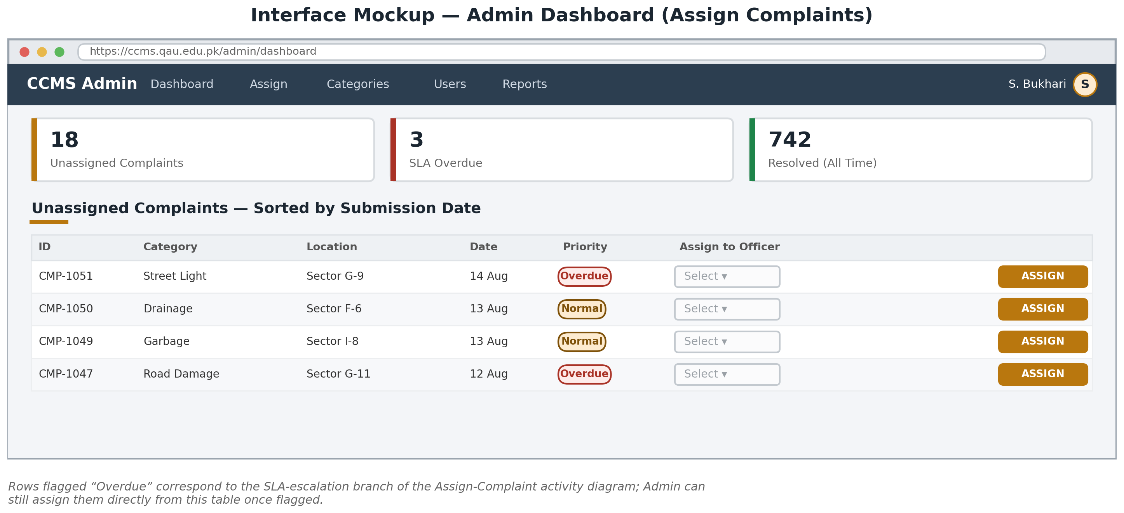
Figure— Admin Dashboard

6.5 Department Officer Panel
The officer panel lists only the complaints assigned to that officer and then it resolved the complaint . Choosing a new status and adding a remark about the complaint , then pressing the Update, and then it triggers and Resolve / Update Complaint sequence.
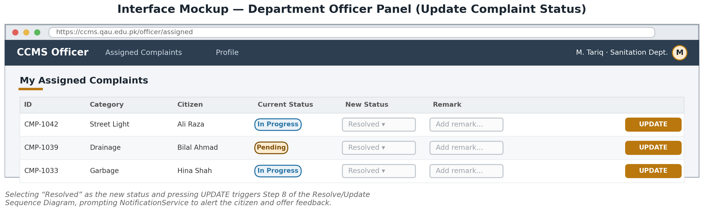
Figure — Department Officer Panel

6.6 Navigation Map
This below diagram shows how the screens in Sections above connect for each role, and how a status change made by a Department Officer reaches the citizen through NotificationService and the Track Complaint screen.
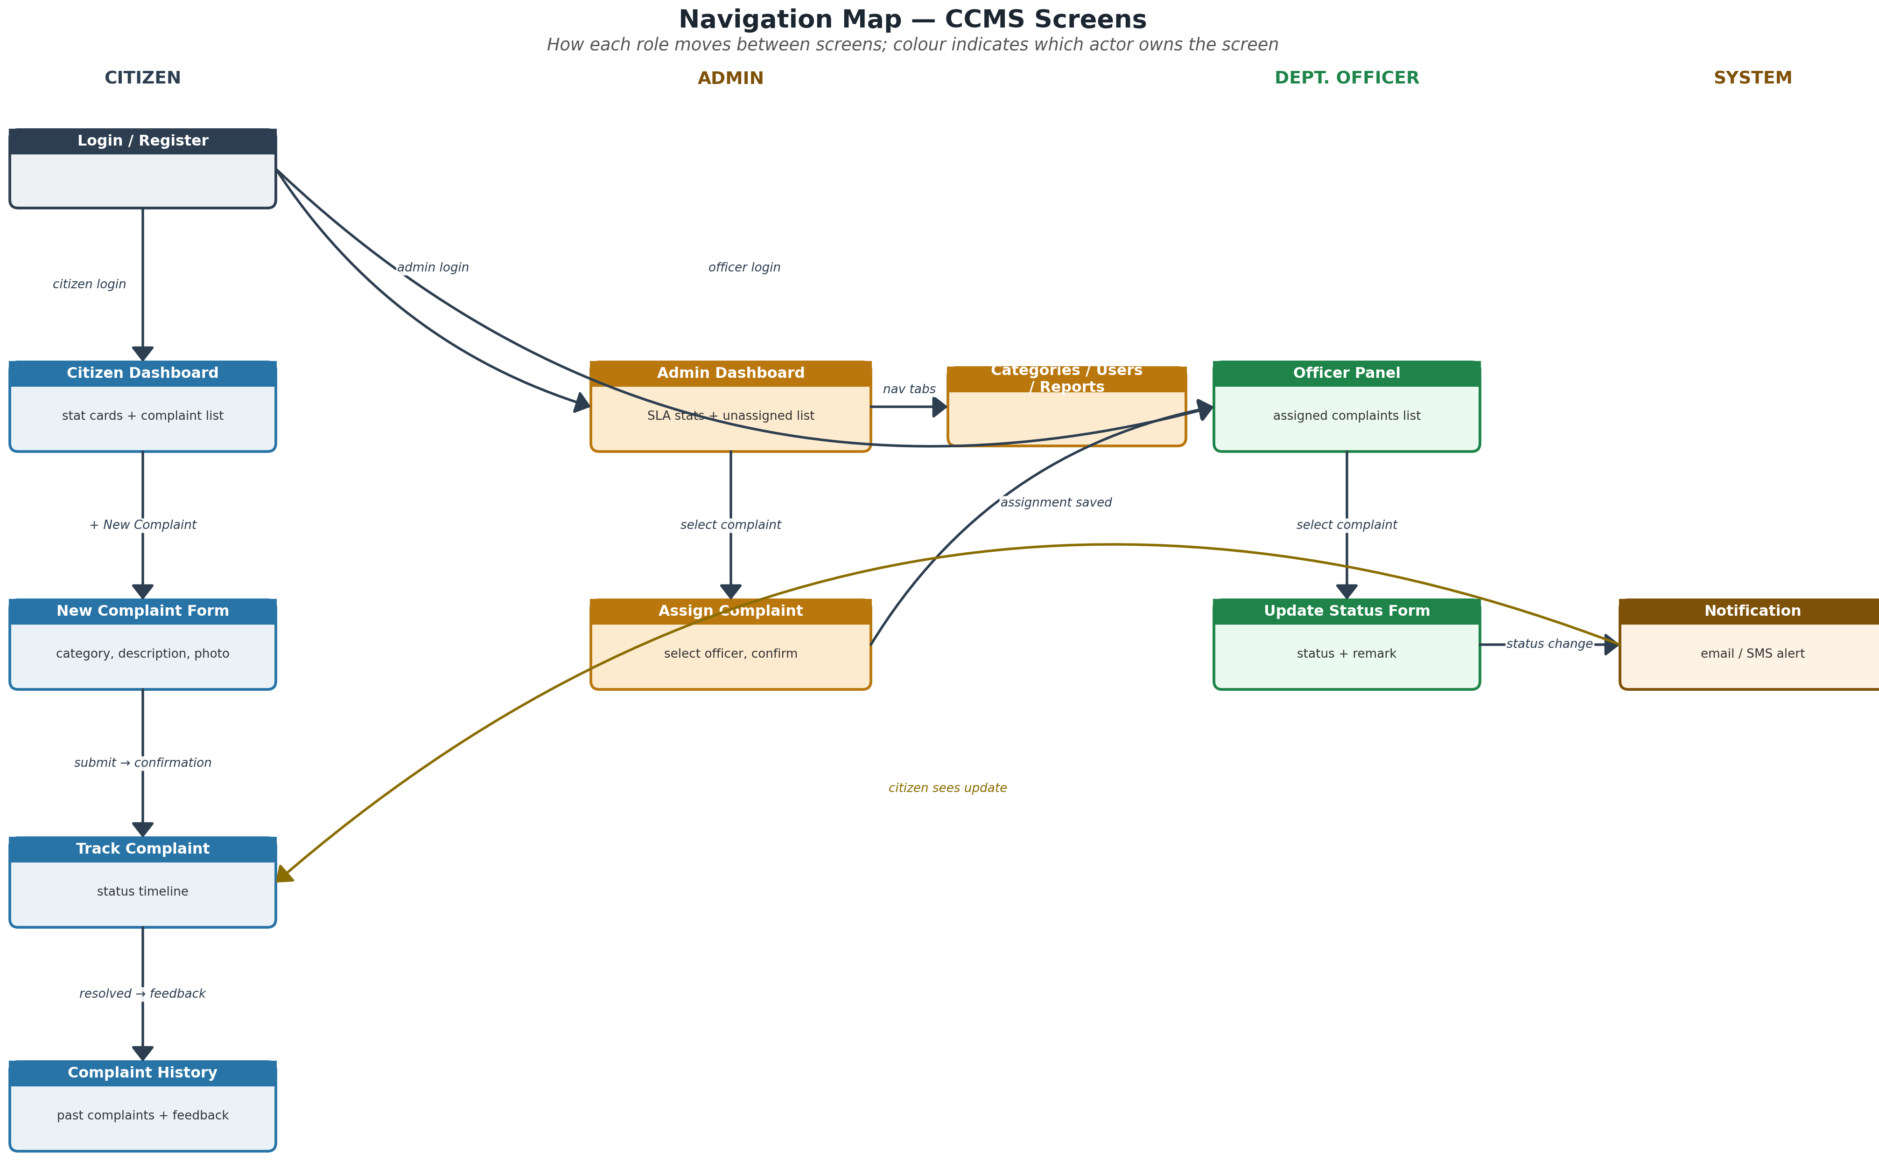

7. Conclusion
This my 4 assignment document has presented the five design artefacts required for Assignment 4 of the Community Complaint Management System project: a layered Architecture Diagram, a Design Class Diagram built on the Domain Modl from Assignment 3, four Activity Diagrams covering the core lifecycle of a complaint, four Interaction sequence diagrams extending the System Sequence Diagrams from Assignment 3 into a full Boundary-Control-Entity , and a set of interface mockups together with a navigation map.
By Taking together with the Analysis Documentation, these models give a complete and consistent picture of both what CCMS needs to remember (the domain and design classes) and how it will be built (the architecture, the object collaborations, and the screens a user will actually see). The design is detailed enough to move directly into implemntation and testing, which is the subject of the next assignment.

QUAID-I-AZAM UNIVERSITY, ISLAMABAD
COMMUNITY COMPLAINT MANAGEMENT SYSTEM
Testing Documentation
Black-Box Testing | White-Box Testing | Unit Testing | Integration Testing | Test Case Design
Submitted By: Shahzaib Khan
Submitted To: Dr. Umer Rashid
Course: Analysis and Design of Software Systems (CS-222)
Assignment 6 — Testing Documentation
Builds on Assignment 4 — Design Documentation

Table of Contents
1. Introduction 4
1.1 Purpose of this Document 4
1.2 Scope 4
1.3 How this Document is Organised 4
2. Testing Strategy 4
2.1 What Software Testing Represents in this Project 4
2.2 Testing Levels and Techniques Applied 5
2.3 Test Case Design Notation Used in this Document 5
2.4 Test Environment and Tools 6
3. Testing — Register Account & Login (UC-01, UC-02) 6
3.1 Feature Under Test 6
3.2 Black-Box Testing 6
3.3 White-Box Testing 7
3.4 Unit Testing 7
3.5 Integration Testing 8
4. Testing — Submit Complaint (UC-03) 8
4.1 Feature Under Test 8
4.2 Black-Box Testing 8
4.3 White-Box Testing 9
4.4 Unit Testing 9
4.5 Integration Testing 10
5. Testing — Assign Complaint (UC-09) 10
5.1 Feature Under Test 10
5.2 Black-Box Testing 10
5.3 White-Box Testing 11
5.4 Unit Testing 11
5.5 Integration Testing 12
6. Testing — Resolve / Update Complaint & Notify Citizen (UC-11) 12
6.1 Feature Under Test 12
6.2 Black-Box Testing 12
6.3 White-Box Testing 13
6.4 Unit Testing 13
6.5 Integration Testing 13
7. Testing — Give Feedback (UC-06) 14
7.1 Feature Under Test 14
7.2 Black-Box Testing 14
7.3 White-Box Testing 14
7.4 Unit Testing 15
7.5 Integration Testing 15
8. Test Summary & Traceability Matrix 15
8.1 Use Case to Test Case Traceability 15
8.2 Defect Severity & Priority Classification 16
9. Conclusion 16

1. Introduction

1.1 Purpose of this Document
In this my document is related to thhe the Testing Documentation for the Community Complaint Management System (CCMS), submitted as Assignment 6 for the course Analysis and Design of Software Systems (CS-222). It builds directly on the Design Documentation submtted for Assignment 4, taking the layered architecture, the design clas diagram, the four activity diagrams, and the four interaction (sequence) diagrams produced there and using them as the basis for a complete set of test cases. Where the Design Documentation askd how the system is built, this document asks how the system is verified — what has to be checked, at what level, and with what technique, before CCMS can be considered ready to hand over. The test cases that follow are written to a level of detail that a tester, or a develper writing automated tests, could execute directly without having to consult the earlier assignmnts to fill in missing information.

1.2 Scope
This document covers the same four actors defined across the SRS (Assignment 2), the Analysis Documentation (Assignment 3), and the Design Documentation (Assignment 4): Citizen, Department Officer, Admin, and the System acting as an automatic Notifier. Testing is organised around the five workflows that carry a complaint through its full lifecycle in CCMS — registering and logging in, submitting a complaint, assigning a complaint, resolving or updating a complaint, and the citizen giving feedback once a complaint is resolved. The first four of these are exactly the four workflows for which Assignment 4 produced a dedicated activity diagram and sequence diagram; the fifth, Give Feedback (UC-06), is included because Section 4.5 of the Design Documentation explicitly links the Resolve/Update workflow forward into it, and because the Feedback class and its association with Complaint are already fully specified in the Design Class Diagram (Assignment 4, Section 3.4).
For each of the five workflows, this document defines the black-box test cases that check the workflow’s observable behaviour against its requirements without reference to how it is implemented; the white-box test cases that check every branch of the workflow’s internal control flow, derived from the decision points already fixed in the corresponding activity diagram; the unit test cases that check the individual classes and operations identified in the Design Class Diagram, each in isolation from its collaborators; and the integration test cases that check the object collaborations shown in the corresponding sequence diagram, confirming that units which pass their individual tests also work correctly together.

1.3 How this Document is Organised
Section 2 sets out the overall testing strategy — what each of the four testing types means in the context of CCMS, and the notation used for every test case table in this document. Sections 3 through 7 present the black-box, white-box, unit, and integration test cases for each of the five workflows in turn: Register Account & Login, Submit Complaint, Assign Complaint, Resolve/Update Complaint, and Give Feedback. Section 8 draws all of this together into a traceability matrix that maps every workflow to its test cases, together with a defect classification scheme to be applied once these test cases are executed. Section 9 closes the document with a short summary of what has been covered and what remains for the maintenance phase that follows.

2. Testing Strategy

2.1 What Software Testing Represents in this Project
Testing is the activity that checks whether the system built from the Design Documentation (Assignment 4) actually behaves the way the SRS (Assignment 2) and the Analysis Documentation (Assignment 3) said it should. Where the design stage asked how CCMS is structured, testing asks whether that structure produces the correct result for every input a Citizen, Admin, Department Officer, or the System’s own Notifier could realistically produce — and fails safely for every input it should reject. No single technique answers that question on its own: a technique that only exercises the system from the outside can miss a branch of code that a black-box input never happens to trigger, and a technique that only exercises code in isolation can miss a defect that appears only once two classes are wired together. For that reason, every one of the five workflows identified in Section 1.2 is tested at all four of the complementary levels described below.

2.2 Testing Levels and Techniques Applied

2.2.1 Black-Box Testing
Black-box testing checks CCMS purely from the outside: a tester supplies an input through one of the interface mockups in Section 6 of the Design Documentation and checks the result against what the SRS and the activity diagrams say should happen, with no knowledge of how ComplaintController, AssignmentController, or any other class is implemented internally. Two techniques keep the black-box test set complete without becoming unmanageably large: equivalence partitioning, which groups inputs the system is expected to treat the same way — for example, any syntactically valid, unregistered e-mail address — into a single representative test case rather than testing every value in the group; and boundary value analysis, which specifically targets the edges of a valid range, such as a password exactly at the minimum length or a rating exactly at 1 or 5, because defects cluster at boundaries far more often than in the middle of a range.

2.2.2 White-Box Testing
White-box testing checks CCMS from the inside, by exercising the actual branches of a workflow’s control flow rather than only its externally visible input/output behaviour. Because this document is derived from the design stage rather than from a specific source file, the control-flow graph for each workflow is taken directly from its activity diagram in Section 4 of the Design Documentation, and every diamond decision symbol is treated exactly as a branch instruction would be in code. For each workflow, this document reports the McCabe cyclomatic complexity of its control-flow graph, computed as V(G) = number of decision points + 1, and provides at least that many independent test paths so that every branch — and, where the diagram loops back on failure, at least one repeated pass through the loop — is exercised at least once.

2.2.3 Unit Testing
Unit testing checks one class or one operation from the Design Class Diagram (Section 3.4) in isolation, with every collaborating class replaced by a stub or a mock so that a failure can be attributed to the unit under test and nowhere else. Repository classes are the thing most often stubbed in this document, since a unit test for AuthController or ComplaintController should not depend on a real database being present. Wherever the Design Documentation named a GRASP pattern for a class — Creator for Complaint, Citizen, and StatusUpdate; Information Expert for Complaint’s own status and officer-link; Pure Fabrication for NotificationService — the unit test cases below are written specifically to confirm that the responsibility actually sits where Section 3.5 of the Design Documentation says it does.

2.2.4 Integration Testing
Integration testing checks that units which already pass their individual unit tests also work correctly once they are wired together exactly as a sequence diagram in Section 5 of the Design Documentation describes. Integration is tested bottom-up, layer by layer, following the layered architecture defined in Section 2 of the Design Documentation: first a controller against its repository (Application → Data Access), then a controller against NotificationService and the external Email/SMS Gateway, and finally a full round trip from one actor’s boundary UI to the shared CCMS Database and back out through a different actor’s boundary UI — for instance, confirming that a complaint a Citizen submits is actually visible, in the correct state, on the Admin’s own dashboard.

2.3 Test Case Design Notation Used in this Document
Every test case in Sections 3–7 is identified by a code of the form TC-<workflow>-<type>-<number>, where <workflow> is a two-letter code for one of the five workflows — RL (Register & Login), SC (Submit Complaint), AC (Assign Complaint), RU (Resolve/Update Complaint), GF (Give Feedback) — and <type> identifies the testing level: BB (Black-Box), WB (White-Box), UT (Unit), IT (Integration). Black-box test cases carry a Priority of High, Medium, or Low, reflecting how central the scenario is to the complaint lifecycle rather than how easy it would be to overlook: High covers the primary success scenario and any case with a security or data-integrity consequence; Medium covers validation and boundary scenarios; Low covers scenarios whose failure would be a usability nuisance rather than a functional defect. White-box test cases are labelled by which branch of the relevant activity diagram’s decision point they exercise, together with the coverage criterion the path set satisfies.

2.4 Test Environment and Tools
CCMS follows the layered, browser-based architecture defined in Assignment 4: a Presentation layer running in the browser, an Application layer of controllers and services, a Data Access layer of repositories, and a relational Data layer. Testing is planned across a matching set of tools: manual, scenario-based execution against the interface mockups in Sections 6.2–6.5 of the Design Documentation for black-box test cases; control-flow / path testing performed against the Application-layer controllers using the decision points already fixed in the activity diagrams for white-box test cases; an automated unit-testing framework such as Jest, consistent with a MERN-based implementation of the Application and Data Access layers, with every repository class stubbed or mocked for unit test cases; and integration testing performed against a dedicated test instance of the CCMS database, so that controller and repository classes are exercised together exactly as the sequence diagrams in Section 5 of the Design Documentation describe.

3. Testing — Register Account & Login (UC-01, UC-02)

3.1 Feature Under Test
This workflow covers the combined Register Account and Login activity described in Section 4.2 of the Design Documentation (Activity Diagram for Register Account & Login) and elaborated for registration in Figure 5.1 (Sequence Diagram — Register Account). It exercises the RegistrationUI/LoginUI boundary classes, AuthController, the Citizen entity, the Staff hierarchy shared by Admin and Department Officer, and CitizenRepository / StaffRepository. Table 4.1 of the Design Documentation identifies the two decision points that anchor this workflow — “Input valid & email unique?” and “Credentials authenticated?” — and both are used directly below as the basis for white-box path coverage.

3.2 Black-Box Testing
Black-box coverage is built from equivalence classes over the registration and login inputs (valid/duplicate/malformed e-mail, policy-compliant/too-short password, matching/mismatched role), plus boundary value analysis at the password-length limit.
Table 3.1 — Black-Box Test Cases: Register Account & Login
ID | Test Scenario | Input / Test Steps | Expected Result | Priority
TC-RL-BB-01 | Register with complete, valid, unique details | Fill name, a well-formed unique email, phone, and a policy-compliant password on the Registration tab; submit | Citizen account is created, a registration confirmation is shown, and the citizen is returned to the Login tab | High
TC-RL-BB-02 | Register with an email already on file | Submit the registration form using an email address that already belongs to another Citizen | Submission is rejected with an “email already registered” validation message; no new account is created | High
TC-RL-BB-03 | Register with a malformed email address | Submit the form with an email missing the “@” symbol (e.g. “aliexample.com”) | Validation error is shown on the email field; the form is redisplayed for correction | Medium
TC-RL-BB-04 | Register with a password shorter than the minimum length | Submit the form with a password one character below the minimum allowed length | Validation error is shown on the password field; account is not created (boundary value, lower bound) | Medium
TC-RL-BB-05 | Register with a required field left blank | Submit the form with the phone field empty, all other fields valid | Validation error highlights the missing field; account is not created | Medium
TC-RL-BB-06 | Log in with correct credentials and matching role | Select role “Citizen”, enter the registered email and correct password, submit | Citizen Dashboard (Design Documentation, Section 6.3) loads for the authenticated account | High
TC-RL-BB-07 | Log in with correct email but wrong password | Enter a registered email with an incorrect password | Login error is shown; the citizen may retry | High
TC-RL-BB-08 | Log in with an email that has never been registered | Enter an email with no matching Citizen or Staff record | Login error is shown; no dashboard is loaded | Medium
TC-RL-BB-09 | Log in to a valid account under the wrong role selection | Enter valid Citizen credentials but select role “Admin” before submitting | Login is rejected as a role mismatch rather than authenticating the citizen into the Admin dashboard | High

3.3 White-Box Testing
The activity diagram in Section 4.2 contains two independent decision points — one per row-pair of the Design Documentation’s Table 4.1 — giving a cyclomatic complexity of V(G) = 2 for each of the registration and login sub-flows considered separately. The four paths below give full branch coverage of both decisions; TC-RL-WB-02 and TC-RL-WB-04 additionally cover the “re-enter” and “retry” loop edges shown in the diagram.
Table 3.2 — White-Box Test Cases: Register Account & Login
Path ID | Path Description | Test Data / Trigger | Expected Result | Coverage
TC-RL-WB-01 | Registration branch where “Input valid & email unique?” evaluates to yes | Complete, valid, unique registration data | Create Citizen Account → Send Registration Confirmation → Receive Confirmation / Proceed to Login | Branch (true)
TC-RL-WB-02 | Registration branch where “Input valid & email unique?” evaluates to no | Duplicate email or an invalid field | Show Validation Error → loop “re-enter” back to Fill Registration Form | Branch (false)
TC-RL-WB-03 | Login branch where “Credentials authenticated?” evaluates to yes | Correct email / password / role combination | Load Dashboard for Authenticated Role → end of flow | Branch (true)
TC-RL-WB-04 | Login branch where “Credentials authenticated?” evaluates to no | Incorrect password | Show Login Error → loop “retry” back to Select Role & Enter Credentials | Branch (false)

3.4 Unit Testing
Unit tests isolate AuthController’s two operations from CitizenRepository and StaffRepository (both stubbed), and check that the Citizen entity itself refuses to be constructed with incomplete data — confirming the Creator responsibility the Design Documentation’s Table 3.2 assigns to AuthController.
Table 3.3 — Unit Test Cases: Register Account & Login
ID | Unit Under Test | Test Description | Expected Result
TC-RL-UT-01 | AuthController.register() | Call register() with an email for which CitizenRepository.findByEmail() (stubbed) returns an existing record | Registration is refused with a duplicate-email result; Citizen.create() is never invoked
TC-RL-UT-02 | AuthController.register() → Citizen.create() | Call register() with valid, unique data and inspect the object passed to create() | The new Citizen object holds exactly the submitted name, email, and phone — confirming the Creator pattern
TC-RL-UT-03 | Citizen entity constructor | Attempt to construct a Citizen with a null or empty email or password | Construction is rejected; no partially-built Citizen object is returned
TC-RL-UT-04 | CitizenRepository.save() | Save a valid, fully-formed Citizen object against a test data store | A new record is written and a citizenID is returned that is distinct from every citizenID already in the store
TC-RL-UT-05 | AuthController.login() | Call login() with a correct email and the matching stored password | Result indicates success and correctly identifies the account’s role (Citizen, Admin, or Department Officer)
TC-RL-UT-06 | AuthController.login() | Call login() once with a wrong password for a real account and once with an email that does not exist | Both calls return the same generic “invalid credentials” result, so a non-existent email cannot be distinguished from a wrong password

3.5 Integration Testing
Integration tests confirm the full RegistrationUI → AuthController → Citizen → CitizenRepository chain against a real (test) data store, and that the shared login flow noted beneath the activity diagram in the Design Documentation, Section 4.2, correctly authenticates all three roles against the right repository.
Table 3.4 — Integration Test Cases: Register Account & Login
ID | Components Integrated | Test Description | Expected Result
TC-RL-IT-01 | RegistrationUI → AuthController → Citizen → CitizenRepository | Submit a valid registration end-to-end and re-read the record from CitizenRepository | A new Citizens row exists whose stored fields match the submitted form and whose citizenID matches the one returned to the UI
TC-RL-IT-02 | AuthController → CitizenRepository (duplicate check) | Register a citizen, then immediately attempt to register a second account with the same email | The second call correctly integrates with the now-populated CitizenRepository and is rejected as a duplicate
TC-RL-IT-03 | RegistrationUI → AuthController → CitizenRepository → LoginUI | Register a new citizen, then immediately log in with the same credentials | Login succeeds on the first attempt, confirming the write from registration is visible to the subsequent read at login
TC-RL-IT-04 | LoginUI → AuthController → StaffRepository | Log in as Admin and, separately, as Department Officer using the shared login flow (Design Documentation, Section 4.2) | Each role authenticates against StaffRepository rather than CitizenRepository and is routed to its own dashboard (Section 6.4 / 6.5)

4. Testing — Submit Complaint (UC-03)

4.1 Feature Under Test
This workflow covers Submit Complaint as diagrammed in Section 4.3 (Activity Diagram for Submit Complaint) and Section 5.3 / Figure 5.2 (Sequence Diagram — Submit Complaint) of the Design Documentation. It exercises the ComplaintFormUI boundary class, ComplaintController, the Complaint entity, ComplaintRepository, and NotificationService. The Design Documentation’s Table 4.2 identifies the single decision point that drives this workflow — “All required fields complete?” — used directly below for white-box path coverage.

4.2 Black-Box Testing
Black-box coverage combines equivalence classes over the four form fields (category, description, location, photo) with boundary value analysis at the descriiption field’s maximum length, and a dedicated case for the “correct & resubmit” loop a citizen experiences after a validation error.
Table 4.1 — Black-Box Test Cases: Submit Complaint
ID | Test Scenario | Input / Test Steps | Expected Result | Priority
TC-SC-BB-01 | Submit a complete, valid complaint | Logged-in citizen selects a category, enters a description and a location, attaches a photo, and submits | A unique Complant ID is generated, the record is saved with status “Pending”, and the citizen receives the Complaint ID for tracking | High
TC-SC-BB-02 | Submit a complaint with no category slected | Leave the category field unselected, fill everything else, submit | Missing/invalid fields are highlihted; the complaint is not saved | High
TC-SC-BB-03 | Submit a complaint with an empty description | Leave the description field blank, fill everyting else, submit | Missing field is highlighted; the complaint is not saved | High
TC-SC-BB-04 | Submit a description at the maximum allowed length | Enter a description exactly at the field’s maximum character limit | Complaint is accepted (boundary value, upper bound) | Medium
TC-SC-BB-05 | Submit a description one character past the maximum allowed length | Enter a description one character longer than the field’s maximum | Validation error shown; complaint is not saved (boundary value, just above upper bound) | Medium
TC-SC-BB-06 | Submit a complaint without attaching a photo | Fill category, description, and location; leave the photo field empty | Complaint is accepted with phto left null, since photo is not one of the fields Table 4.2 treats as mandatory | Low
TC-SC-BB-07 | Correct and resubmit after a validation error | Trigger the “no” branch of TC-SC-BB-02, then fill in the missing category and resubmit | Complaint is now accepted and a Complaint ID is generated (exercises the “correct & resubmit” loop) | Medium

4.3 White-Box Testing
With one decision point, V(G) = 2 for this diagram; the first two patths below give full branch coverage, and the third exercises the loop edge across more than one iteration to confrm no state from a failed attempt leaks into the next.
Table 4.2 — White-Box Test Cases: Submit Complaint
Path ID | Path Description | Test Data / Trigger | Expected Result | Coverage
TC-SC-WB-01 | Path wheere “All required fields complete?” evaluates to yes | Fully valid form daata | Generate Unique Complaint ID → Save Complaint Record (status = Pending) → Notify Admin → Receive Complaint ID | Branch (true)
TC-SC-WB-02 | Path where “All required fields complete?” evaluatesd to no | One or more required fields missing or invalid | Highlight Missing/Invalid Fields → loop “correct & resubmit” back to Fill Category, Description, Location & Attach Photo | Branch (false)
TC-SC-WB-03 | Loop-repeat path: two consecutive validation failures before success | Attempt 1 missing category; attempt 2 missing description; attempt 3 fully valid | The loop executes twice before falling through to Generate Unique Complaint ID, with no leftover state from the failed attempts | Loop coverage

4.4 Unit Testing
Unit tests isolate ComplaintController’s validation logi from Complaint.create() and ComplaintRpository (both stubbed), and confirm that Complaint’s own defaultng behaviour — status and submissionDate — does not depend on what the caller supplies.
Table 4.3 — Unit Test Cases: Submit Complaint
ID | Unit Under Test | Test Description | Expected Result
TC-SC-UT-01 | ComplaintController.submitComplaint() | Call submitComplaint() with the category field missing | Method returns a validation-error result; Complaint.create() and ComplaintRepository.save() are never invoked
TC-SC-UT-02 | Complaint entity defaults (create()) | Construct a Complaint via create() supplying only category, description, location, and photo | status defaults to “Pending” and submissionDate defaults to the current system date, regardless of caller input
TC-SC-UT-03 | ComplaintRepository.save() | Save several distinct Complaint objects in sequence against a test store | No two saved complaints are ever assigned the same complaintID
TC-SC-UT-04 | NotificationService.notify() | Observe calls to notify() during a successful submitComplaint() and during a failed one | notify(admin, complaintID) fires exactly once for the successful case and zero times for the failed case
TC-SC-UT-05 | ComplaintController.submitComplaint() | Call submitComplaint() with a description over the maximum length | Method returns a validation-error result before ComplaintRepository is ever reached

4.5 Integration Testing
Integration tests confirm the full ComplaintFormUI → ComplaintController → Complaint → ComplaintRepository chain against a test database, that NotificationService reliably reaches Admin, and that a newly submitted complaint is immediately visible on both the citizen’s own dashboard and the Admin’s unassigned list — the hand-off into Assign Complaint (Section 5).
Table 4.4 — Integration Test Cases: Submit Complaint
ID | Components Integrated | Test Description | Expected Result
TC-SC-IT-01 | ComplaintFormUI → ComplaintController → Complaint → ComplaintRepository | Submit a valid complaint end-to-end, then query ComplaintRepository.findByStatus(“Pending”) | The newly submitted complaint is returned by the query with status “Pending” and the same complaintID shown to the citizen
TC-SC-IT-02 | ComplaintController → NotificationService → Email/SMS Gateway | Submit a valid complaint and inspect the Notifications table | Exactly one notification record addressed to Admin is created, referencing the new complaint’s ID
TC-SC-IT-03 | ComplaintRepository → Citizen Dashboard | Submit a complaint as a given citizen, then reload that citizen’s dashboard (Section 6.3) | The new complaint appears immediately in “My Complaints” with status “Pending”
TC-SC-IT-04 | ComplaintRepository → Admin Dashboard | Submit a complaint, then reload the Admin Dashboard’s Unassigned Complaints list (Section 6.4) | The complaint appears in the unassigned list, confirming Submit Complaint integrates correctly with Assign Complaint through the shared Complaints table

5. Testing — Assign Complaint (UC-09)

5.1 Feature Under Test
This workflow covers Assign Complaint as diagrammed in Section 4.4 (Activity Diagram for Assign Complaint, with SLA Escalation Check) and Section 5.4 / Figure 5.3 (Sequence Diagram — Assign Complaint). It exercises AssignmentUI, AssignmentController, the Complaint entity’s assignTo() and updateStatus() operations, ComplaintRepository, and NotificationService. The Design Documentation’s Table 4.3 identifies the SLA-escalation decision point — “Any complaint older than SLA threshold?” — and the SLA itself is defined in the SRS as FR14 (Assignment 2), as noted beneath the activity diagram in Assignment 4.

5.2 Black-Box Testing
Black-box coverage exercises both branches of the SLA flag from the Admin’s point of view, the successful and rejected assignment-confirmation scenarios, and boundary value analysis at the SLA threshold itself.
Table 5.1 — Black-Box Test Cases: Assign Complaint
ID | Test Scenario | Input / Test Steps | Expected Result | Priority
TC-AC-BB-01 | Unassigned list contains a complaint past the SLA threshold | Open the Unassigned Complaints list with one complaint older than the SLA threshold present | That complaint is displayed flagged “Overdue” / High Priority (Admin Dashboard, Section 6.4) | High
TC-AC-BB-02 | Unassigned list contains only complaints within the SLA threshold | Open the list where every complaint is younger than the threshold | All complaints display as “Normal” priority; none are flagged | Medium
TC-AC-BB-03 | Assign a Pending complaint to an available officer | Select a complaint, select a Department Officer, confirm | Complaint status becomes “In Progress”, the officer is linked, and the officer is notified | High
TC-AC-BB-04 | Confirm an assignment with no officer selected | Select a complaint, leave the officer selector on its placeholder value, click Assign | Validation error is shown; the assignment is not confirmed | Medium
TC-AC-BB-05 | Complaint age exactly equal to the SLA threshold | Assign a complaint whose age exactly equals the configured SLA threshold (FR14, Assignment 2 SRS) | Complaint is classified consistently according to the defined rule at the boundary itself (boundary value analysis) | Medium
TC-AC-BB-06 | Attempt to assign an already-assigned complaint | Attempt to assign a complaint that already has an officer linked | Complaint is not offered in the unassigned list, or the duplicate assignment is rejected | Medium

5.3 White-Box Testing
One decision point gives V(G) = 2; the two paths below give full branch coverage, and a third checks that the decision is re-evaluated per complaint rather than once for the whole unassigned list.
Table 5.2 — White-Box Test Cases: Assign Complaint
Path ID | Path Description | Test Data / Trigger | Expected Result | Coverage
TC-AC-WB-01 | Path where “Any complaint older than SLA threshold?” evaluates to yes | A complaint older than the SLA threshold is present in the list | Flag Complaint as High Priority/Escalated → merge back → Select a Complaint to Assign | Branch (true)
TC-AC-WB-02 | Path where “Any complaint older than SLA threshold?” evaluates to no | No complaint in the list exceeds the SLA threshold | Flow skips the flagging step and proceeds directly to Select a Complaint to Assign | Branch (false)
TC-AC-WB-03 | Mixed-list path: some complaints flagged, some not, within the same list load | List contains both an overdue and a within-threshold complaint | The overdue complaint is flagged and the within-threshold complaint is not — the decision is evaluated per complaint, not once for the whole list | Branch coverage (per item)

5.4 Unit Testing
Unit tests isolate the SLA-classification logic at its boundary, confirm Complaint.assignTo() changes only the officer-link attribute (Information Expert, per the Design Documentation’s Table 3.2), and confirm Complaint.updateStatus() rejects an invalid backward transition out of “Resolved”.
Table 5.3 — Unit Test Cases: Assign Complaint
ID | Unit Under Test | Test Description | Expected Result
TC-AC-UT-01 | AssignmentController — SLA check | Evaluate the check for a complaint age exactly at, just below, and just above the SLA threshold | “At threshold” and “above threshold” both classify as escalated; “just below” does not
TC-AC-UT-02 | Complaint.assignTo(officerID) | Call assignTo() on a Complaint object and inspect every attribute afterward | Only the officer-link attribute changes; description, location, submissionDate, and photo are unchanged (Information Expert)
TC-AC-UT-03 | Complaint.updateStatus(“In Progress”) | Call updateStatus(“In Progress”) on a Complaint whose current status is already “Resolved” | The invalid backward transition is rejected; status remains “Resolved”
TC-AC-UT-04 | AssignmentController — unassigned list builder | Build the unassigned list against a stubbed ComplaintRepository containing both assigned and unassigned complaints | Only complaints with a null officer link (findByStatus(“Pending”)) are returned

5.5 Integration Testing
Integration tests confirm that a confirmed assignment persists as a single consistent update in ComplaintRepository, that NotificationService reaches the correct officer, and that the change is visible on both the Officer Panel (Section 6.5) and the citizen’s Track Complaint screen (Section 6.3).
Table 5.4 — Integration Test Cases: Assign Complaint
ID | Components Integrated | Test Description | Expected Result
TC-AC-IT-01 | AssignmentController → Complaint → ComplaintRepository | Confirm an assignment, then re-read the same complaint from ComplaintRepository | The re-read record shows both the new officer link and status “In Progress” as a single consistent update
TC-AC-IT-02 | AssignmentController → NotificationService | Confirm an assignment and inspect the Notifications table | Exactly one notification addressed to the selected Department Officer is created, referencing the correct complaintID
TC-AC-IT-03 | ComplaintRepository → Officer Panel & Citizen Track Complaint screen | Confirm an assignment, then reload the Officer Panel (Section 6.5) and the citizen’s Track Complaint screen | The complaint appears on the officer’s “My Assigned Complaints” list, and the citizen sees the updated “In Progress” status
TC-AC-IT-04 | Application-layer SLA flag → Admin Dashboard | Trigger the SLA-escalation flag for a complaint and reload the Admin Dashboard | The “Overdue” badge in Section 6.4 correctly reflects the flag computed in the Application layer

6. Testing — Resolve / Update Complaint & Notify Citizen (UC-11)

6.1 Feature Under Test
This workflow covers Resolve / Update Complaint & Notify Citizen as diagrammed in Section 4.5 (Figure 4.4) and Section 5.5 / Figure 5.4 (Sequence Diagram — Resolve / Update Complaint) of the Design Documentation. It exercises UpdateStatusUI, ComplaintUpdateCtrl, the StatusUpdate entity, the Complaint entity’s updateStatus() operation, ComplaintRepository, and NotificationService. The Design Documentation’s Table 4.4 identifies the decision point — “New status = Resolved?” — used below for white-box path coverage.

6.2 Black-Box Testing
Black-box cooverage exercises both notification variants produced by the decision point, an authorisation check on which officer may update which complaint, and the duplicate-resolution edge case.
Table 6.1 — Black-Box Test Cases: Resolve / Update Complaint & Notify Citizen
ID | Test Sceario | Input / Test Steps | Expected Result | Priority
TC-RU-BB-01 | Mark an assigned complaint Resolved | Officer selects a complaint in “In Progress”, sets status to “Resolved”, adds a remark, updates | Status becomes “Resolved”; citizen is notified with a “Complaint Resolved” message and prompted for feedback | High
TC-RU-BB-02 | Move a complaint from Pending to In Progress | Officer selects a Pending complaint, sets status to “In Progress”, adds a emark, updates | Status becomes “In Progress”; citizen receives a generic “Complaint Status Updated” message, with no feeback prompt | High
TC-RU-BB-03 | Update status with an empty remark | Officer changes status but leaves the remark field blank | System either accepts the update with an empty remark or rejects it — test both equivalence classes to confirm which rule is actually built | Medium
TC-RU-BB-04 | Officer attempts to update a complaint not assigned to them | Officer opens the Update Status form for a cmplaint assigned to a different DepartmentOfficer | Update is rejected; compaint status is unchanged | High
TC-RU-BB-05 | Resolve an already-resolved complaint | Officer attempts to set status to “Resolved” a second time on a complaint already marked “Resolved” | Duplicate resolution is rejected, or treated as a no-op with no second StatuUpdate record created | Medium

6.3 White-Box Testing
In One decision point gives V(G) = 2; the two paths below give full branch coverage of the diagram.
Table 6.2 — White-Box Test Cases: Resolve / Update Complaint & Notify Citizen
Path ID | Path Description | Test Data / Trigger | Expected Result | Coverage
TC-RU-WB-01 | Path where “New status = Resolved?” evaluates to yes | Officer sets the new status to “Resolved” | Record Status Update → Notify Citizen: “Complaint Resolved” + prompt for feedback | Branch (true)
TC-RU-WB-02 | Path where “New status = Resolved?” evaluates to no | Officer sets the new status to “In Progress” | Record Status Update → Notify Citizen: “Complaint Status Updated” | Branch (false)

6.4 Unit Testing
Unit tests confirm CompaintUpdateCtrl always records exactly one StatusUpdate per call (Creator, per the Design Documentation’s Table 3.2), that Complaint.updateStatus() only accepts the three defined status values, and that the correct notification variant is chosen from the new status alone.
Table 6.3 — Unit Test Cases: Resolve / Update Complaint & Notify Citizen
ID | Unit Under Test | Test Description | Expected Result
TC-RU-UT-01 | ComplaintUpdateCtrl.updateComplaintStatus() → StatusUpdate.create() | Call updateComplaintStatus() with an old status of “In Progress” and a new status of “Resolved” | Exactly one StatusUpdate record is created, whose oldStatus and newStatus fields match the trasition exactly
TC-RU-UT-02 | Complant.updateStatus() | Attempt to set status to a value outside {Pending, In Progress, Resolved} | Call is rejected; the status attribute is unchanged and no invalid value is ever storeg
TC-RU-UT-03 | ComplaintUpdateCtrl — notification selection | Call updateComplaintStatus() with new status “Resolved” and, separately, with “In Progress” | The “Resolved + feedback prompt” message is sent only for the Resolved case; the generic message is sent otherwise
TC-RU-UT-04 | StatusUpdate.recordUpdate() | Supply a remark at the field’s maximum defined length | The saved remark exactly matches the submitted text, character for character, with no truncation

6.5 Integration Testing
Integration tests confirm the Complaint record and its StatusUpate history stay consiistent after a real write, that a citizen sees a resolution on the Track Complaint screen immdiately, and that a resolved complaint correctly becomes eligible for the Give Feedback workflow that follows.
Table 6.4 — Integration Test Cases: Resolve / Update Complaint & Notify Citizen
ID | Components Integrated | Test Description | Expected Result
TC-RU-IT-01 | ComplaintUpdateCtrl → Complaint → StatusUpdate → ComplaintRepository | Update a complaint’s status, then re-read both the Complaint record and its StatusUpdate history | The Complaint’s current status and the latest StatusUpdate entry are consistent with each other
TC-RU-IT-02 | ComplaintUpdateCtrl → NotificationService → Track Complaint screen | Mark a complaint “Resolved” and reload the citizen’s Track Complaint screen (Section 6.3) | The citizen receives the resolution notification and the timeline reflects “Resolved” immediately
TC-RU-IT-03 | Resolve/Update workflow → Give Feedback workflow | Mark a complaint “Resolved”, then attempt to submit feedback for it as the citizen | The complaint is now eligible for feedback, confirming the hand-off into UC-06 described in Section 4.5

7. Testing — Give Feedback (UC-06)

7.1 Feature Under Test
Give Feedback is the workflow the Design Documentation names, in Section 4.5, as the forward link from Resolve/Update Complaint. Assignment 4 does not include a dedicated activity or sequence diagram for it, so the control flow used for white-box design below is derived directly from the Feedback entity and its association with Complaint in the Design Class Diagram (Section 3.4): a Complaint may receive at most one Feedback (multiplicity 0..1), submitted by the Citizen who filed it, once that complaint’s status is “Resolved”. This workflow exercises the Citizen entity’s giveFeedback() operation, the Feedback entity’s submitFeedback() operation, and FeedbackRepository.

7.2 Black-Box Testing
Black-box coverage exercises the eligibility rule (Resolved-only, one feedback per complaint) as two rejection scenarios, plus boundary value analysis at both ends of the 1–5 rating scale and an equivalence class for the optional comment field.

ID | Test Scenario | Input / Test Steps | Expected Result | Priority
TC-GF-BB-01 | Submit feedback for a resolved complaint with no prior feedback | Citizen opens a “Resolved” complaint with no existing Feedback link, enters a rating and a comment, submits | Feedback is saved and linked to that complaint | High
TC-GF-BB-02 | Attempt feedback on a complaint that is not yet resolved | Citizen attempts to submit feedback for a complaint still “Pending” or “In Progress” | Submission is rejected, or the feedback option is not offered for that complaint | High
TC-GF-BB-03 | Attempt a second feedback on the same complaint | Citizen attempts to submit feedback for a complaint that already has a Feedback record | Submission is rejected, enforcing the 0..1 multiplicity between Complaint and Feedback | High
TC-GF-BB-04 | Submit the lowest valid rating | Enter rating = 1 (lower bound of the rating scale) | Feedback is accepted (boundary value, lower bound) | Medium
TC-GF-BB-05 | Submit the highest valid rating | Enter rating = 5 (upper bound of the rating scale) | Feedback is accepted (boundary value, upper bound) | Medium
TC-GF-BB-06 | Submit a rating outside the valid range | Enter rating = 0, and separately rating = 6 | Both are rejected with a validation error (boundary value, just outside both ends) | Medium
TC-GF-BB-07 | Submit a valid rating with no comment | Enter rating = 4 and leave the comment field blank | Feedback is accepted, since only rating is treated as mandatory | Low

7.3 White-Box Testing
The single eligibility rule — “Complaint is Resolved AND has no existing Feedback” — is treated as one compound decision, giving V(G) = 2; its two operands are covered individually by the black-box equivalence classes above
Table 7.2 — White-Box Test Cases: Give Feedback
Path ID | Path Description | Test Data / Trigger | Expected Result | Coverage
TC-GF-WB-01 | Path where the complaint is Resolved and has no exising Feedback | Resolved coplaint, Feedback association currently null | submitFeedack() proceeds → Feedback is created, saved, and linked to the Complaint | Branch (allowed)
TC-GF-WB-02 | Path where the complaint is not Resolved, or already has Feedback | Complaint still “In Progress”, or already carries a Feedback record | submitFeedback() is rejcted before a Feedback object is created | Branch (rejected)

7.4 Unit Testing
Unit tests confirm Feedback.submitFeedback() rejects an out-of-range rating, that dateGiven is always system-assigned rather than caller-supplied, and that the 0..1 multiplicity between Complaint and Feedback is enforced at the association level.
Table 7.3 — Unit Test Cases: Give Feedback
ID | Unit Under Test | Test Description | Expected Result
TC-GF-UT-01 | Feedback.submitFeedback() | Attempt to submit with rating = 0 and, separately, rating = 6 | Both are rejected; a Feedback object is not constructed for either out-of-range value
TC-GF-UT-02 | Feedback entity — dateGiven | Construct a Feedback object at submission time | dateGiven is set automatically to the current system date, not a caller-supplied value
TC-GF-UT-03 | Complaint–Feedback association | Attempt to attach a second Feedback object to a Complaint that already has one | The second attachment is refused; the original Feedback record is untouched (0..1 multiplicity enforced)

7.5 Integration Testing
Integation tests confirm a submited Feedback record is correctly persisted and displayed alongside its parent complaint on the Compaint History screen, and that the Resolved-only rule is enfoced end-to-end from the Citizen Dashboard through to FeedbackRepository.
Table 7.4 — Integration Test Cases: Give Feedback
ID | Components Integrated | Test Description | Expected Result
TC-GF-IT-01 | Feedback → FeedbackRepository → Complaint History screen | Submit valid feedback, then reload the citizen’s Complaint History screen | The feedback’s rating and comment appear alongside the corresponding resolved complaint
TC-GF-IT-02 | Citizen Dashboard → giveFeedack() → FeedbackRepository | Attempt to submit feedback for a complaint that is not yet Resolved, end-to-end rom the dashboard | The attempt is blocked before reaching FeedackRepository; no orphan Feedback record is creatd

8. Test Summary & Traceability Matrix

8.1 Use Case to Test Case Traceability
Table 8.1 summarises how many teest cases of each type were designed for every workfslow, so that coverage can be checked at a glance against Sections 3–7. Table 8.2 lists, for each workflow, the exact range of test case IDs a reviewer should look up in this document.
Table 8.1 — Test Case Counts by Workflow and Testing Level
Workflow | Use Case(s) | Black-Box | White-Box | Unit | Integration | Total
Register Account & Login | UC-01, UC-02 | 9 | 4 | 6 | 4 | 23
Submit Complaint | UC-03 | 7 | 3 | 5 | 4 | 19
Assign Complaint | UC-09 | 6 | 3 | 4 | 4 | 17
Resolve/Update Complaint | UC-11 | 5 | 2 | 4 | 3 | 14
Give Feedback | UC-06 | 7 | 2 | 3 | 2 | 14
Total | — | 34 | 14 | 22 | 17 | 87
Table 8.2 — Test Case ID Ranges by Workflow
Workflow | Section | Test Case ID Range
Register Account & Login | Section 3 | TC-RL-BB-01–09, TC-RL-WB-01–04, TC-RL-UT-01–06, TC-RL-IT-01–04
Submit Compaint | Section 4 | TC-SC-BB-01–07, TC-SC-WB-01–03, TC-SC-UT-01–05, TC-SC-IT-01–04
Assign Complaint | Section 5 | TC-AC-BB-01–06, TC-AC-WB-01–03, TC-AC-UT-01–04, TC-AC-IT-01–04
Resolve/Update Complaint | Section 6 | TC-RU-BB-01–05, TC-RU-WB-01–02, TC-RU-UT-01–04, TC-RU-IT-01–03
Give Feedback | Section 7 | TC-GF-BB-01–07, TC-GF-WB-01–02, TC-GF-UT-01–03, TC-GF-IT-01–02

8.2 Defect Severity & Priority Classification
The classifiction below is the scheme to be applied once the test cases in Sections 3–7 are executed against the implemented system, so that any defect found is logged, prioritised, and retested consisently rather than on an ad-hoc basis.
Table 8.3 — Defect Severity Classification
Severity | Definition | Example in CCMS
Critical | Defect blocks a core workflow entirey or corrupts stored data. | A submitted complaint is never saved, or CitizenRepository.save() silently drops fields.
Major | Defect breaks aworkflow’s correct behaviour but a workaround exists. | The SLA-escalaton flag never appears, but Amin can still assign compaints manually.
Minor | Defect affects a secondry or edge-case scenario. | An empty remark is accepted when the design intends it to be mandatory.
Cosmetic | Defect is visual or wording only, with no functional impact. | A status badge uses the wrong shade of gold from the Design Documentation’s Table 6.1 colour-coding scheme.
Table 8.4 — Defect Priority Classification
Priority | Meaning | Typical Response
High | Must be fixed befor  e the next round of testing. | Fixed and retested before any further test cases are executed.
Medium | Should be fixed before the release this test cycle supports. | Scheduled within the current testing cycle.
Low | Can be deferred to a later maintenance cycle. | Logged and revisited after the current cycle closes.

9. Conclusion
This documet has presented the testing documentation required for Assignment 6 of the Community Complaint Management System project: a four-level tsting strategy — black-box, white-box, unit, and integration — applied consistently across the five workflows that carry a complaint through its full lifecycle, together with eighty-seven individual test cases collected into the tables of Sectios 3 through 7, and a traceability matrix in Section 8 that ties every one of those test cases back to the workflow, the decision point, and the class or sequence diagram in the Design Documentation (Assignment 4) that it was derived from.
Taken together with thje Requirement Specification (Assignment 2), the Analyssis Documentation (Assignment 3), and the Design Documentation (Assignment 4), this document closes the loop on wat CCMS needs to remember, how it is built, and now how it will be verified before it can be trusted to mannage real complaints from real citizens. What remains, once these test cases are executed against the implemented system, is to log any defect found using the classification , retest it, and carry forward only the residual risk that genuinely belongs to the maintenance phase that follows.

